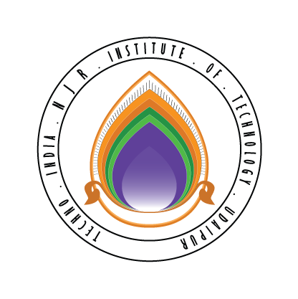 | Techno India NJR Institute of Technology  Bhamashah (RIICO) Industrial Area, Kaladwas, Udaipur

Date: 1/05/2017

Php Programming Training

Php Programming training will be conducted from 11th May 2017 (Monday). Training will be conducted by Ms. Poornima Dave. It is mandatory for all second-year students. The class timing will be from 9:00 am to 11:00 am.

Gaurav Kumawat
(Department Coordinator)

