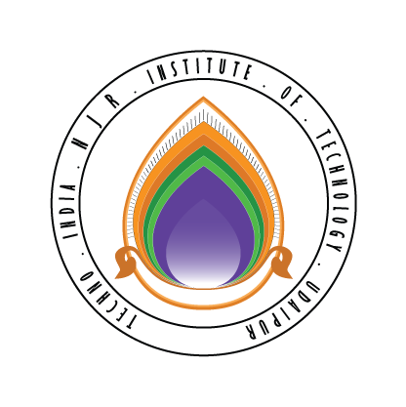 | Techno India NJR Institute of Technology  Bhamashah (RIICO) Industrial Area, Kaladwas, Udaipur

Date: 1/06/2018

Php Programming Training

Php Programming training will be conducted from 4th June 2018 (Monday). Training will be conducted by Mr. Pankaj Ameta. It is mandatory for all second-year students. The class timing will be from 11:00 am to 1:00 pm.

Gaurav Kumawat
(Department Coordinator)

