IBM Learning Portal

Techno NJR’s NJR i3 Labs developed a Learning Management for IBM ICE team which is mainly developed just to provide online learning content to all the students of university/college who are associated to IBM-ICE program. That platform is compatible for the Web and Mobile version and students can access learning content or e-content while sitting anywhere in the world with portal credentials.

With this project IBM-ICE team can organize and arrange virtual class and virtual labs for the students. Even students able to read the online e-content even in offline mode. This is project is working on both iOS and Android platform and capturing the user activities both offline and online mode. With those captured data the dashboard is capable enough to do the analytics and can produce the reports accordingly.

That portal can also allocate projects to students where mentor and project lead can interact with each other and achieve the objective of the project allocated to their team and mentor can help them about with technical skills while college admin can keep track on the project timeline.

Also with that portal any college admin can host hackathon for all the associated college with the help of IBM-ICE team where all the students can participate and college SPoC can host the problem statements and can do the collaborative work where jury members and hackathon mentors can evaluate the completion together and students can upload their code.

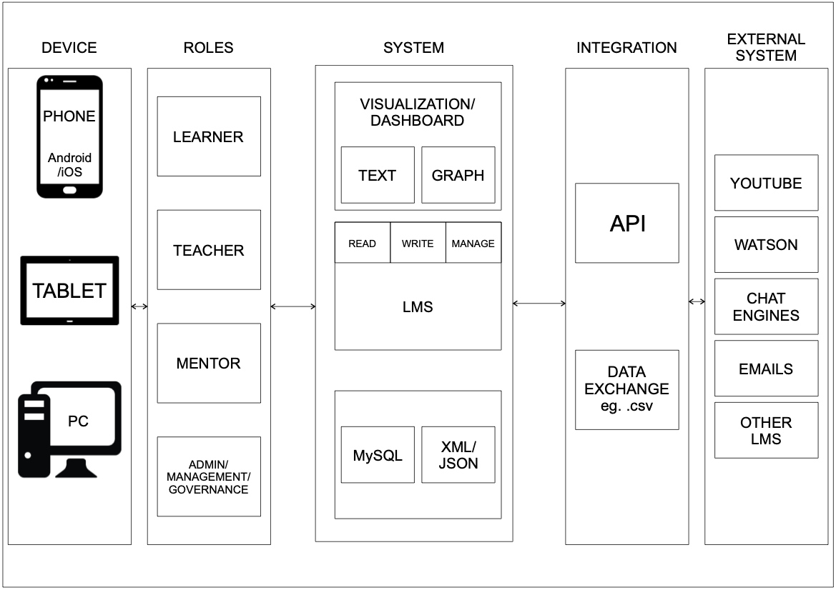

COVID-19 Citizen Isolation Application

COVID-19 apps are mobile software applications that use Digital contact tracing in response to the COVID-19 pandemic, i.e. the process of identifying persons ("contacts") who may have been in contact with an infected individual.

COVID management in the Udaipur city has turned into a perennial chase, as the staff of Udaipur Municipal Corporation and District Collector Office have come to realize, thanks to uncooperative citizens. While they continue to grapple with contact tracing, keeping an eye on people in the high-risk category, running after relatives of deceased COVID-19 patients for the funeral, they are now landed with the added responsibility of keeping tab on people put on home quarantine or isolation, with many of them turning incommunicado after getting home.

We have developed a Mobile application with Admin dashboard where we can monitor the activity of suspect and quarantine citizen if they step out from their house, so we can get information via Mobile GPS and local authorities can take any action against them.

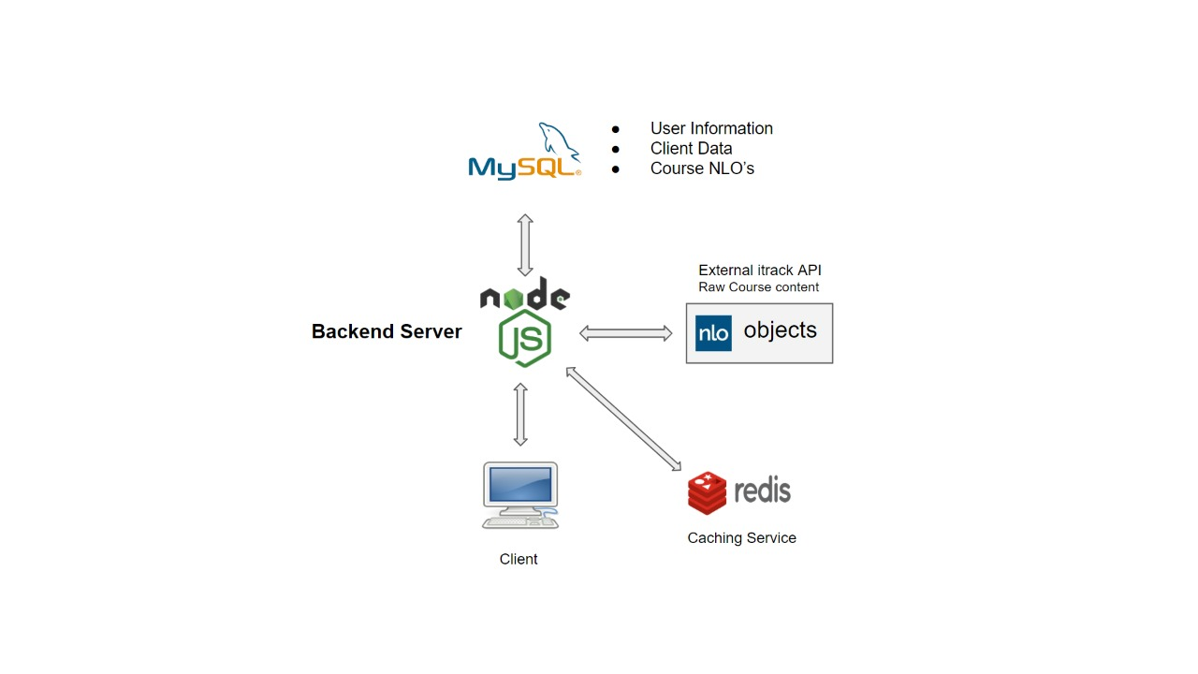

Video Intelligence Analytics Python Web App

We have developed Video Intelligence Analytics software to improve production on a production line. With our video cameras can provide an overview of the department and be directly integrated into the production line or systems to monitor processes where they happen, this enables any management to intervene and respond in good time. The analysis of video recordings can provide useful approaches towards optimizing production processes and designing them to be more stable and more secure.

With this video analysis software organization can improve their production and development. Video surveillance helps to secure the material quality of the development environment: Scarce raw materials, valuable equipment and intermediate results are reliably protected against theft and manipulation. Video surveillance can thus contribute to a sustained increase in quality and enhance the economic benefits from large-scale developments and keep them at a high level.

