4.1.1
Projector Smart Class Rooms
STATUS OF PROJECTORS
S.No. | Model | Availability mode | Department | Location
 | RICOH PJ TS100 | Mounted | EEE | MAT LAB
 | RICOH PJ TS100 | Mounted | CSE | Projector Room II-Floor
 | RICOH PJ TS100 | Mounted | CSE | I-Carnegie Lab-III
 | RICOH PJ TS100 | Portable | ECE | ECE Dept.
 | RICOH PJ TS100 | Mounted | ECE | VLSI Lab
 | EPSON- H375C | Mounted | ME | ME- Cad Lab
 | RICOH PJ TS100 | Mounted | ME | ME-Design Lab
 | EPSON- H375C | Mounted | CSE | Seminar Hall (ic Lab)  (Top Floor)
 | RICOH PJ TS100 | Mounted | CSE | OOPS Lab
 | EPSON – H375C | Mounted | CSE | I-Carnegie Lab-I
 | EPSON EH-TW5300 | Mounted | Administrator | Seminar Hall
 | RICOH PJ TS100 | Mounted | Basic Science | Language Lab
 | NEC NP 100G (9643406CJ) | Mounted | CSE | DBMS LAB
 | RICOH PJ TS100 | Mounted | ME | A- Wing A-Class Room
 | RICOH PJ TS100 | Mounted | ME | A- Wing C-Class Room
 | RICOH PJ TS100 | Mounted | ME | CNC LAB New Balding
 | DILP | Portable | CSE | Server Room
 | Sony MP-CD1 Compact Pocket Size Mobile Projector | Portable | Director | Director
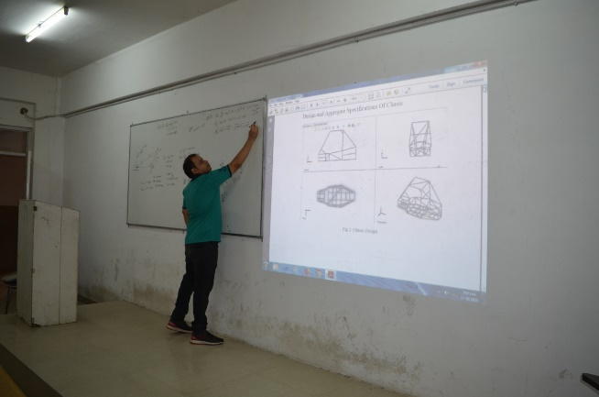 | 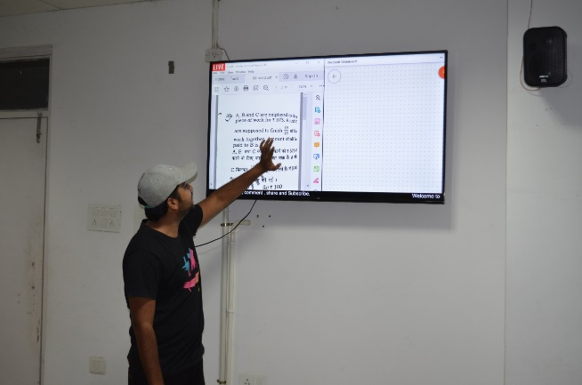 | 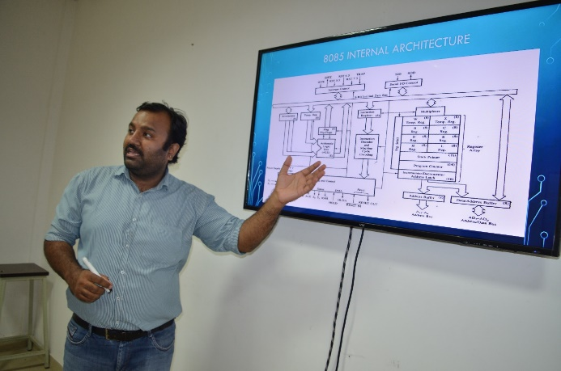
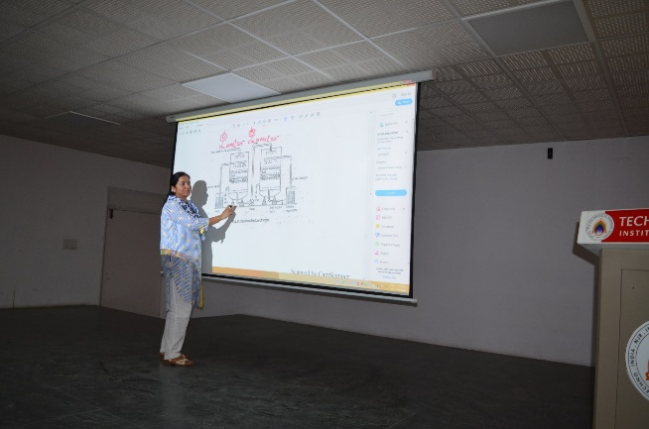 | 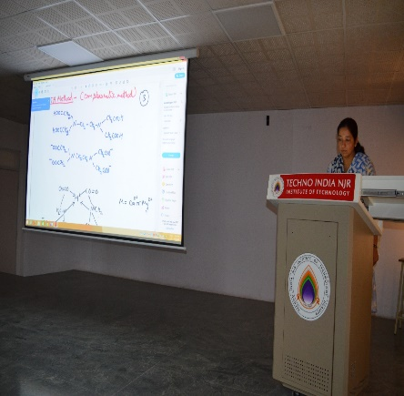 | 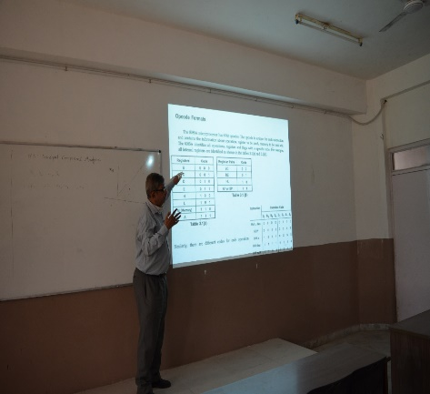
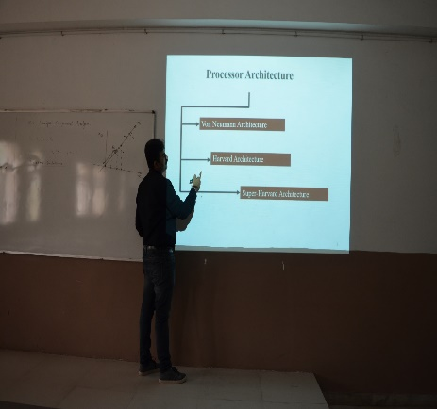 | 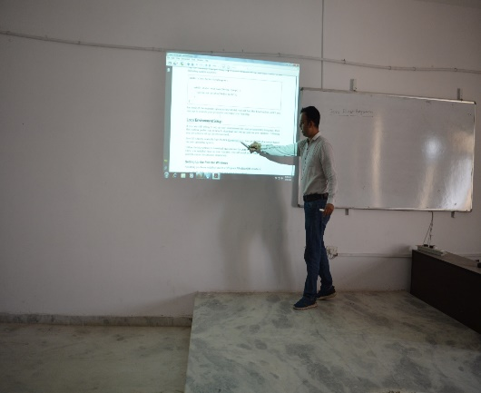 | 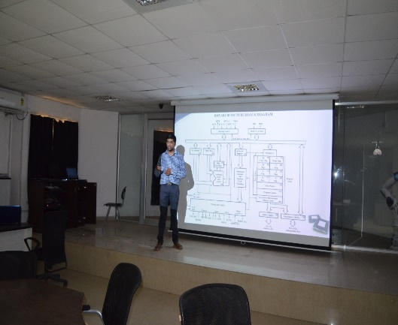

Big Screen (LED TV)
S.No. | Model | Availability mode | Department | Location
 | TCL 138(55inch) cm 4K Smart LED TV | Mounted | Admin | External Wall of Director Room
 | VU Smart LED TV 138(55inch) cm  Ultra HD | Mounted | DSA LAB | External Wall of B Wing
 | MarQ by Flipkart Dolby 65 inch (165 cm) Ultra HD (4K) Smart LED TV | Mounted | i3 LAB | Wall of i3 LAB
 | Vu Pixelight 140cm (55 inch) Ultra HD (4K) LED Smart TV | Mounted | ic LAB | Wall of ic LAB
 | Vu Premium 80cm (32 inch) HD Ready LED Smart Android TV (32US) | Portable | Guest Room | Wall of Guest Room
 | Mi 4A PRO 80 cm (32) HD Ready LED Smart Android TV with Google Data Saver | Mounted | i3 LAB | Wall of ARVR
 | Vu Ultra Smart 123cm (inch) Full HD LED Smart TV (49SM) | Mounted | Bord Room | Wall of Bord Room

Smart Digital Podium

S.No. | Model | Availability mode | Department | Location
 | Digital Podium GEL 19P  Display 21.5” View Sonic Panel with Stylus Bosch 120w Amplifier Control Panel with HDMI Port PC Would BE Acer Core i3 ,4GB Ram,500GB HDD With Windows 10and Wireless System | Install | Admin | Seminar Hall

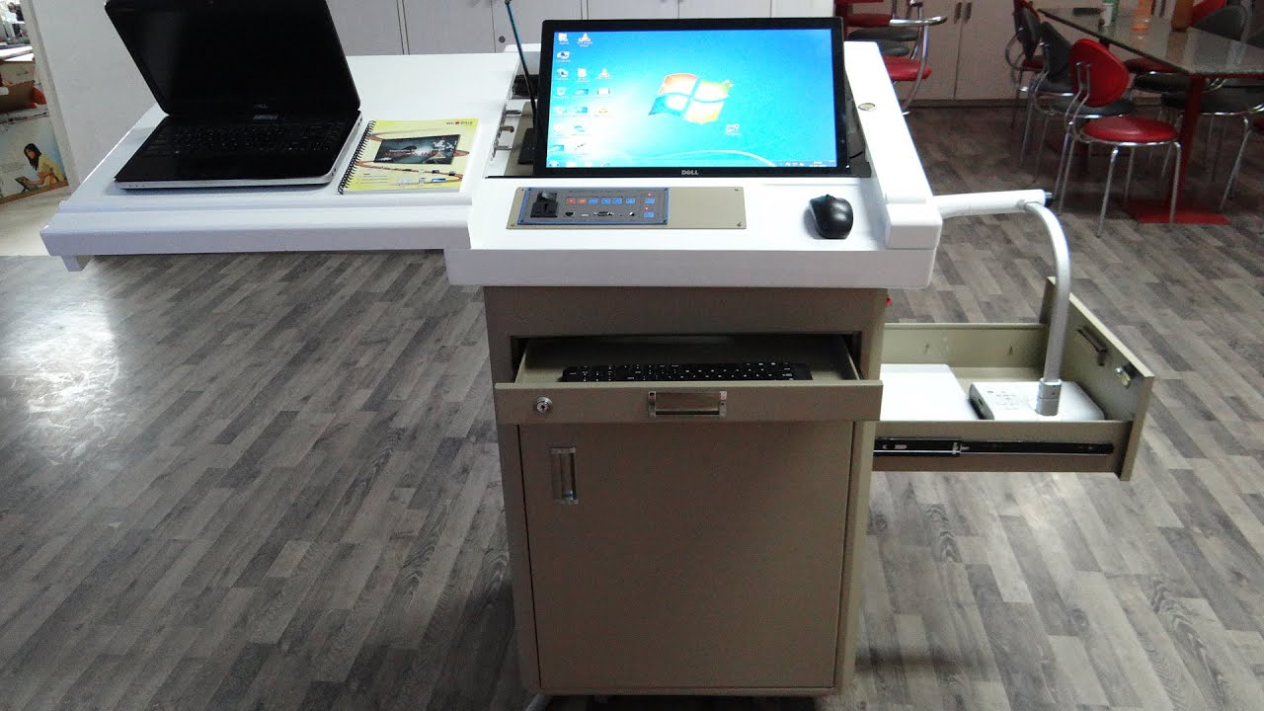

Studio Online Lecture VC

S.No. | Model | Availability mode | Department | Location
 | Logitech Conference Cam Group  Part No. 960-001054 | Install | Admin | Bord Room

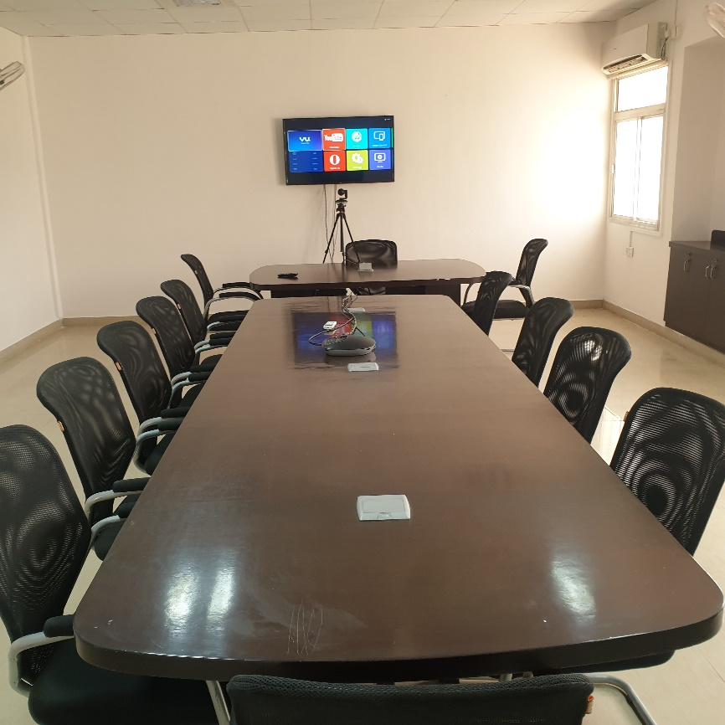

Audio System

S.No. | Model | Availability mode | Department | Location
 | Sony MHC -V81D HI-FI System  With 1 Qut. Shure Wireless Microphone Model No. SVX24/PG58 | Portable | I3 LAB | I3 LAB
 | I3 System, Behringer Power Amplifier Inuke NU1000 With Tannoy Install Wall Speaker DVS8 Black with 2 Qut. Shure Wireless Microphone Model No. SVX24/PG58 With Studio master AIR 8U Analog Mixing Console With 1Qut Studio master ER 58 / EL 58 Head Set Wireless Microphone | Install | Admin | Seminar Hall
 | I5 System Dell high definition audio Studio master Amplifier DJA 550 With Allen & Heath Mixer Zed1002/X with JBL Speaker Control 1 with 2 Qut. Shure Mike SVX24/PG58 | Install | CSE | ICLAB
 | C2d System, Ahuja amplifier 4000 with 4 Qut Wall Speaker 30Watts 2-Way Speaker SMX-302T with 1 Qut STUDIOMASTER ER 7H SERIES HANDHELD WIRELESS MICROPHONE With 1Qut Studio master ER 58 / EL 58 Head Set Wireless Microphone | Install | CSE | language lab
 | C2d System, Ahuja PA Cassette Recorder Amplifier watt with 2 Qut Wall Speaker 30Watts 2-Way Speaker SMX-302T with GM-615. PA Gooseneck Microphone | Install | CSE | A-wing  (101 Room)
 | C2d System with Bosch 120w Amplifier Control Panel with 2 Qut Wall Speaker 30Watts 2-Way Speaker SMX-302T with 1 Qut STUDIOMASTER ER 7H SERIES HANDHELD WIRELESS MICROPHONE | Install | CSE | A-wing  (107 Room)
 | C2d System, with Bosch 120w Amplifier Control Panel with Ahuja column speaker ASC-20T 15W/100V PA | Install | CSE | Icar-1,2,3, LAB
 | Ahuja PSX 600DP PA with Amplifier | Portable | CSE | Server Room
 | iBall Raaga Classic 14 W Laptop/Desktop Speaker (Black, 2.1 Channel) | Portable | MECH. | MECH.  (Lokesh Sir)
 | Black 2.1 Tarang Lion iball Speaker | Portable | CSE | Server Room
 | IBall Tarang Lion 2.1 Channel Home Cinema System | Portable | CSE | Server Room

