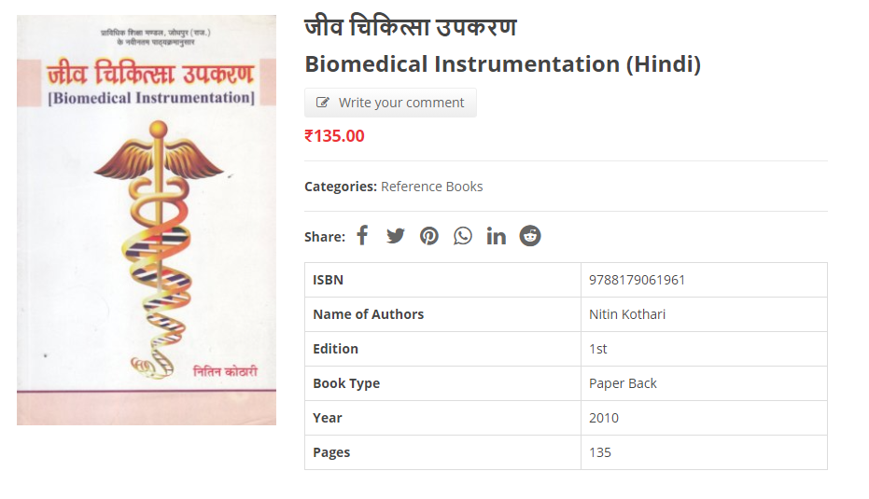

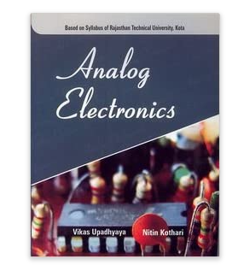

Publisher : Himanshu Publications (1 January 2010)

* Language : English
* ISBN-10 : 8179062155
* ISBN-13 : 978-8179062159
* Item Weight : 45.3 g