Smart India Hackathon is a nationwide initiative to provide students with a platform to solve some of the pressing problems we face in our daily lives, and thus inculcate a culture of product innovation and a mindset of problem-solving. The first three editions SIH2017, SIH2018 and SIH2019 proved to be extremely successful in promoting innovation out-of-the-box thinking in young minds, especially engineering students from across India.

SIH 2017 – Techno NJR was proud to be selected as one of 26 Nodal Center for Smart India Hackathon 2017 (world’s biggest Hackathon) where 500 students worked nonstop for 36 hours to find digital solutions to various problems of Ministry of Railways.

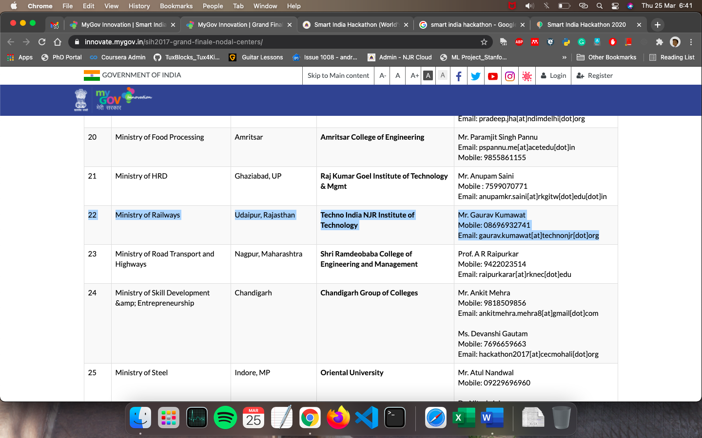

Image SRC: https://innovate.mygov.in/sih2017-grand-finale-nodal-centers/

SIH 2018 (Software Editions) – With this Software edition of Smart India Hackathon 2018, Once again Techno India NJR was become one of the Nodal Center for the Ministry of Railways. In this edition 265 students worked for 36 hours nonstop to solve the 28 problem statements of Ministry of Railways.

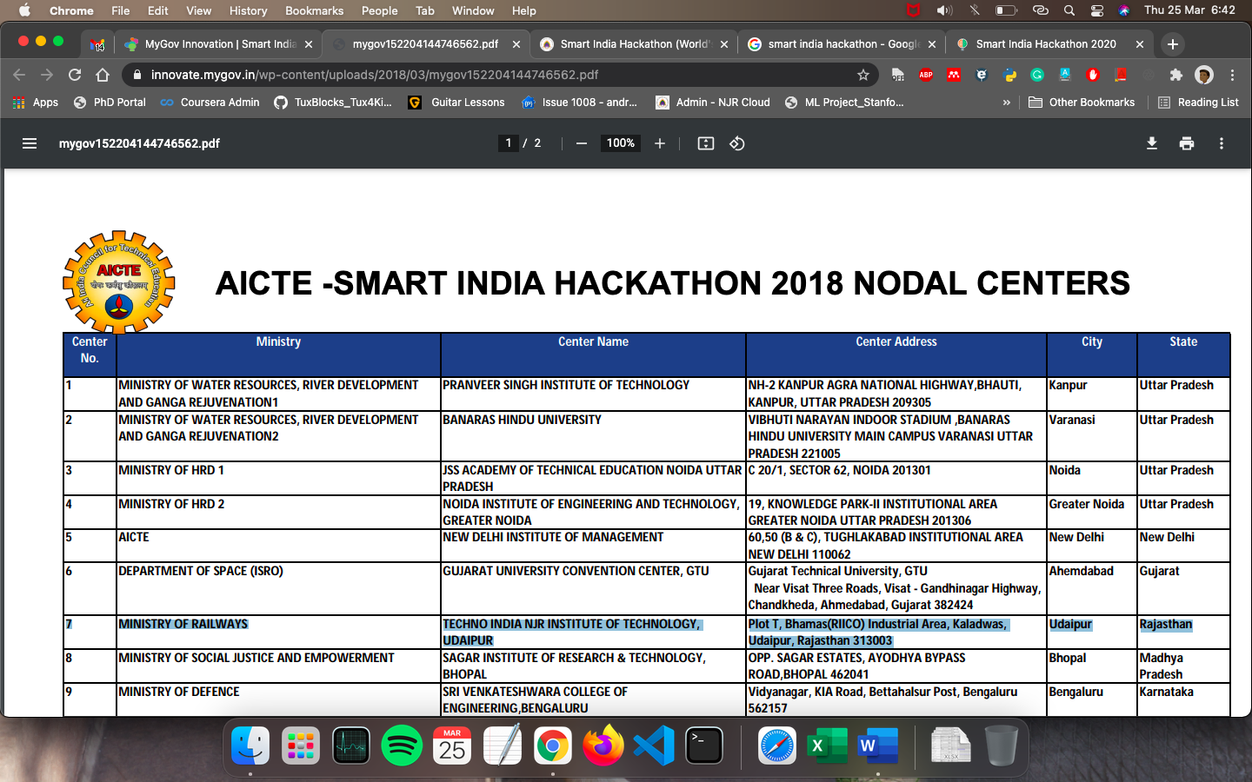
Image SRC : https://innovate.mygov.in/wp-content/uploads/2018/03/mygov152204144746562.pdf

SIH 2019 (Software Edition) – Smart India Hackathon 2019 (World’s largest Hackathon) had organized on March 2-3, 2019 in Udaipur. Techno NJR was the Nodal Center for companies Quick Heal Technologies and Bridgestone Tyres as a part of it and 20 teams (120 students) and their mentors worked nonstop for 36 hours to find the digital solutions to various problems.

It is a matter of pride that Udaipur was chosen as one of 48 Nodal Centers for organizing Word’s largest Innovation Hackathon. Udaipur based Engineering College; Techno India NJR Institute of Technology is chosen as a Nodal Centre for the 3rd consecutive year after their successful hosting of Smart India Hackathon.

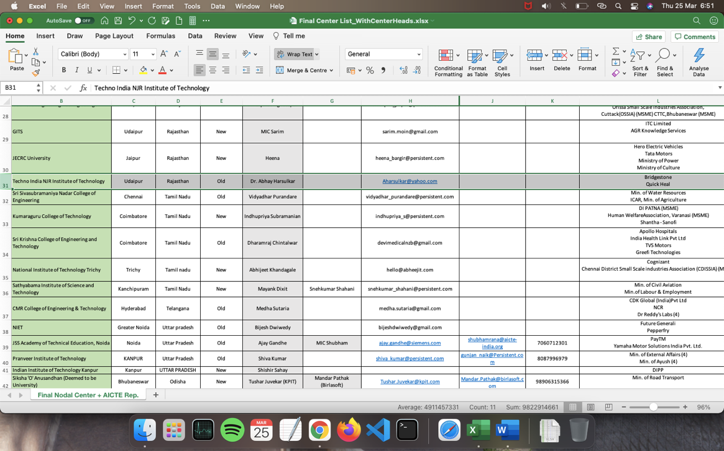
Image SRC: https://drive.google.com/file/d/15djQJ0XYhRUUygB3LpgTd7heN8BARN1V/view?usp=sharing

