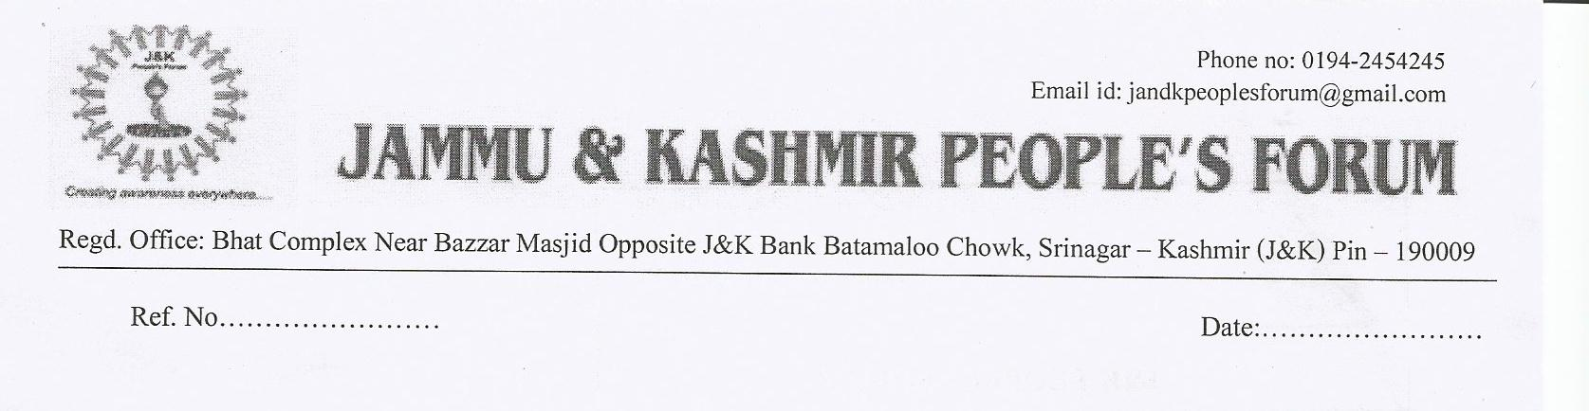
To

Shri R. S. Vyas
Honourable Chairman,
Techno India Udaipur,
Rajasthan.

Subject: - Deputation of students under CSR.

Dear Sir,
J&K People’s Forum is highly indepted to your goodself for having taken lead in discharging Corporate Social Responsibility by taking orphans and poor meritorious students from Kashmir last year and they are currently pursuing their studies successfully. This year also we are forwarding the documents of the following students their academic status against each.
 | NAME | PARENTAGE | ADDRESS | MARKS OBTAINED IN X | TOTAL MARKS X | MARKS OBTAINED IN XII | TOTAL MARKS XII | PARCENTAGE IN X11
1 | SEMIM AKHTAR HUSSAIN | MD SAFIUL HUSSAIN | KHARGULI P/O UZANBAZAR KAMRUP ASSAAM | 433 | 600 | 402 | 600 | 67
2 | KULSUMA DILAWAR | LATE DILAWAR AHMAD RATHER | GOSHBUGH PATTAN | 441 | 500 | 412 | 500 | 82.4
3 | HUMAIRA QADIR | LATE GHULAM QUADIR NAJAR | QURIGAM QUAZIGUND | 313 | 500 | 379 | 500 | 75.8
4 | TABASUM MAQBOOL | MOHAMMAD MAQBOOL TELI | TARATPORA HANDWARA | 397 | 500 | 403 | 500 | 80.6
5 | RASHID RIYAZ KHAN | NIGHAT HASEEN | LAL BAZAR | 415 | 500 | 353 | 500 | 70.6

It is certified that all the four candidates are highly deserving and require your patronage. Three female students have been brought up by J&K Yateem Trust and their warden will be accompanying them to Techno on the date you communicate to us.
As per as North-East is concern we have received the documents of Semim Akhter Hussain which too are sent here with. She will be meeting your goodself personally on 6th of August 2015 in Hotel Ashoka, M.J. Road Guwahati. We have also talked to Mrs. Sameena who is a political leader and Chairperson of Minority Cell in Assam and is available on cell no. 09716061887. She can also assist in identifying other required candidates. From Manipur also one Mr. Syed Ullah a veteran political activist was also contacted. He too has assured assistance in your task. His phone no. is 09436100786. As far as Kashmiri Migrant are concerned, we are yet to receive response from them. Hope we will be communicating to you on the subject shortly.

Kindly confirm the documents and communicate us the date on which the students should report to you in the college.

With regards

Yours Sincerely,

Syed Nassar Ullah Shah
Chairman
Mob no.: 09419013010
Email id: nassarullah11@gmail.com

