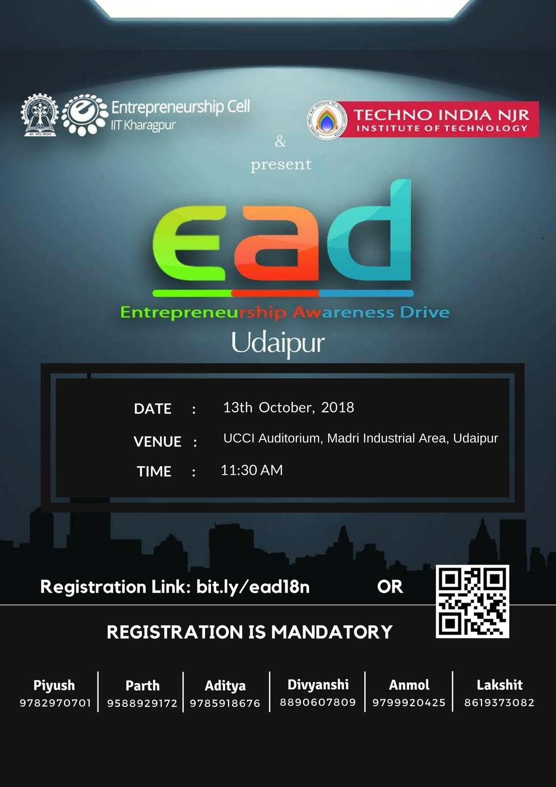EAD 2018

|  |  |
| --- | --- |
|  |  |
|  |  |

EAD - Entrepreneurship Awareness Drive 2018, 13th October 2018

|  |  |
| --- | --- |
|  |  |
|  |  |