**Techno India NJR Institute of Technology, Udaipur NAAC**

**7.1.1**

**Measures initiated by Institution for the promotion of Gender Equity during the last five years.**

***Measures initiated by the Institution for the promotion of gender equity during the last five years.***

Describe gender equity & sensitization in curricular and co-curricular activities, facilities for women on campus etc., within 500 words

***Provide Web link to:***

Annual gender sensitization action plan

Specific facilities provided for women in terms of:

a. Safety and security

b. Counselling

c. Common Rooms

d. Day care centre for young children

***e. Any other relevant information***

Techno India NJR Institute of Technology is taking certain specific initiatives to facilitate gender equity and their development and empowerment. Our Gender Positive Initiatives are –

**Internal Complaint Committee** – The committee consists of Principal and three senior faculty members including one woman and local police station in-charge. This committee looks after any grievance and tries to solve at the earliest.

**Anti-Ragging Committee** – A dedicated anti-ragging committee is there. Till date the faculty members are so vigilant that no case of anti-ragging has been reported.

**Safety and Security** - In order to maintain safety and security to the girls students and woman faculties, a committee has been constituted for redress of grievances. Our Internal Compliances committee stays alert all the time to prevent any sexual abuse to words students and female workers. We also focus on preventing this kind of harassments by using secret monitory services, which keep a keen eye on the entire campus. Deployment of 128 CCTVs across the campus for round-the-clock surveillance. Separate timings for girls to utilize the GYM.

**Counselling** - The major objective of the counselling centre is to facilitate Academic, Emotional, Social and cognitive development of the students hence to empower them in their learning and personal development. Other than students, parents and teachers are also getting the benefits from the counsellor in order to pave a path to the students inside the campus and in their homes. Here in Techno NJR we look into the most common reasons college students seek counselling; to achieve this goal college is taking several steps.

**Common Room**- There is a dedicated common room separate for boys and girls.

**1. Safety and Security.**

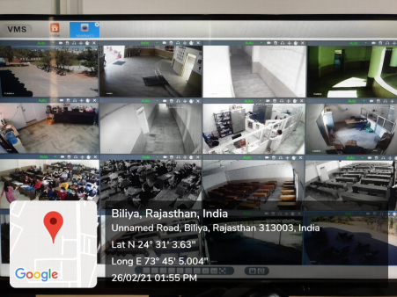

**2. Common Rooms.**

