**Techno India NJR Institute of Technology**

**7.1.2:**

**4. Smart Meter Sensor-based energy conservation**

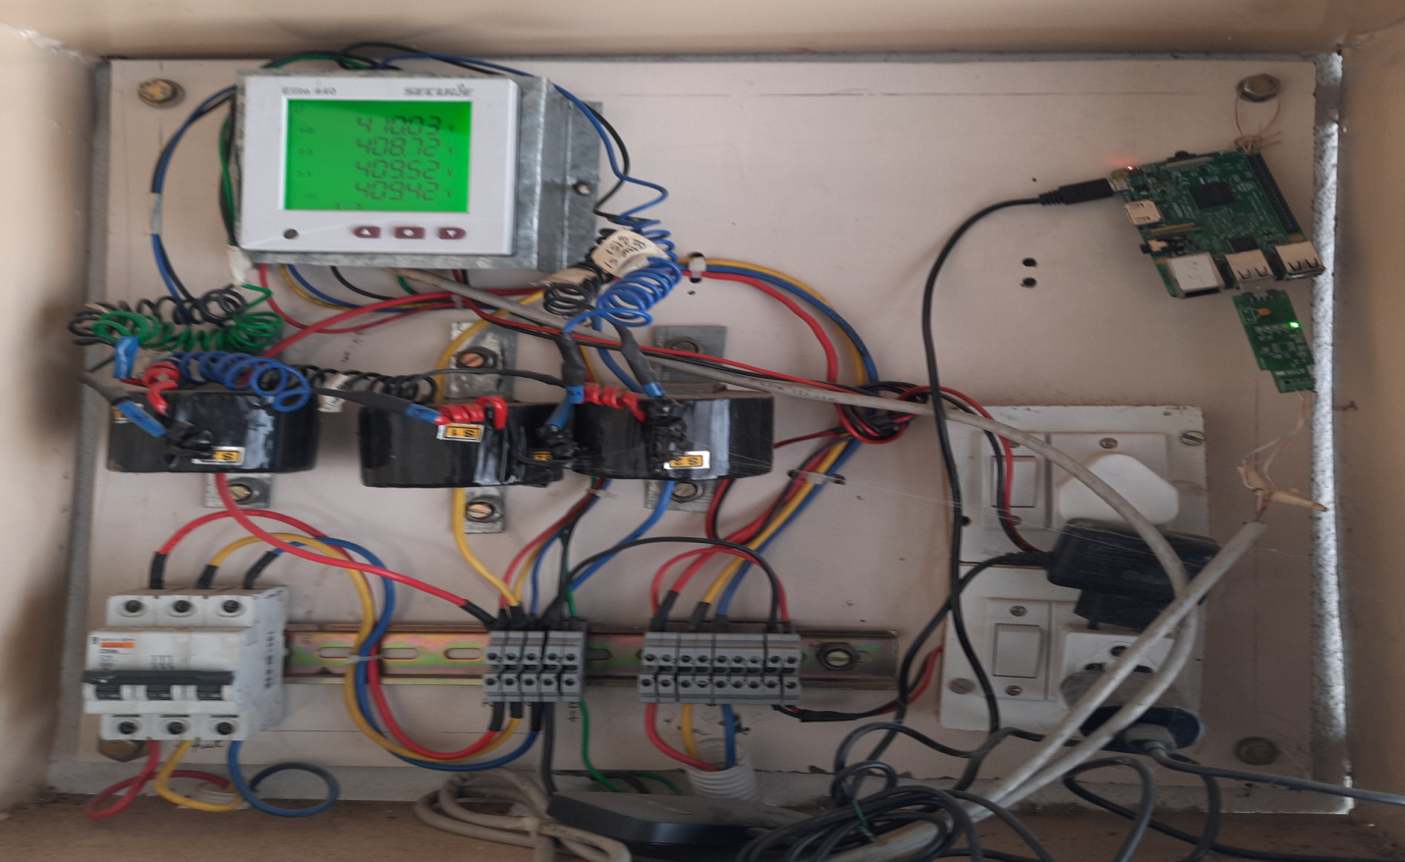

Smart Meter Sensor-based energy conservation

Key points:

* Problem Statement
* Solution
* Technology Details
  + - IOT
    - CLOUD

Problem Statement:

There is a need for a viable method for metering and calculating the energy consumption. Innovative software-based solutions that could provide live information related to consumption of electricity by various appliances. Methods for making it more cost-effective.

Solution:

* Eliminates manual meter readings
* Quick and Accurate Detailed Reading
* Real Time Monitoring for Distributors as well as Consumers
* Optimizes income with existing resources

Technology Details:

**Cloud Computing**: Cloud computing is A model for enabling convenient, on-demand network access to A shared pool of configurable computing resources (E.G., Networks, servers, storage, applications, and services) that can be rapidly provisioned and released with minimal management effort or service provider interaction.

**Internet of Things**: The internet of things refers to the ever-growing network of physical objects that feature an IP address for internet connectivity, and the communication that occurs between these objects and other internet-enabled devices and systems.

**Data Analytics**: Data analysis is a process of inspecting, cleansing, transforming, and modeling data with the goal of discovering useful information, informing conclusions, and supporting decision-making.

Use case Diagram:

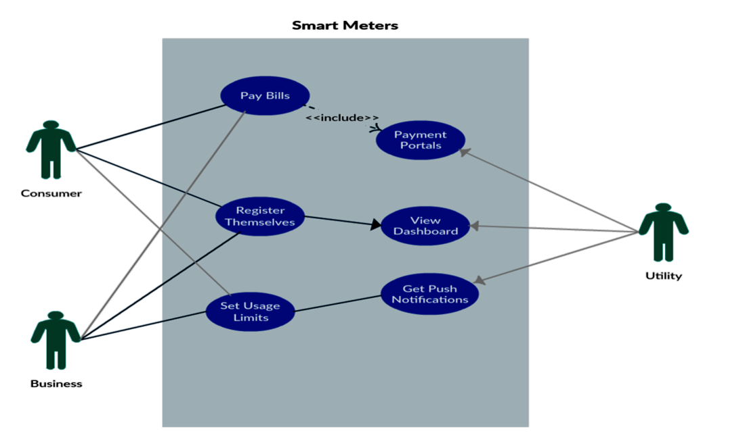

Dashboard:

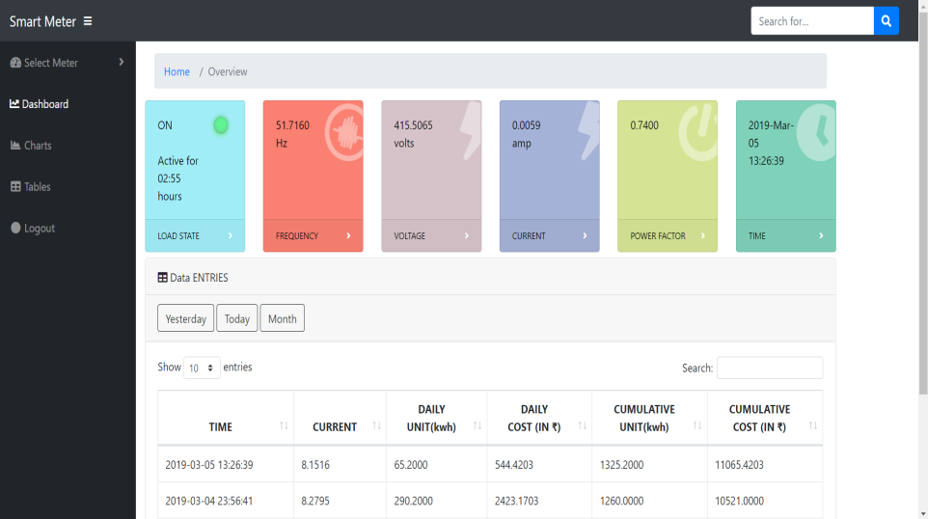

Analytics Based on different Parameters:

