7.1.2:
5. Use of LED bulbs/power efficient equipment:
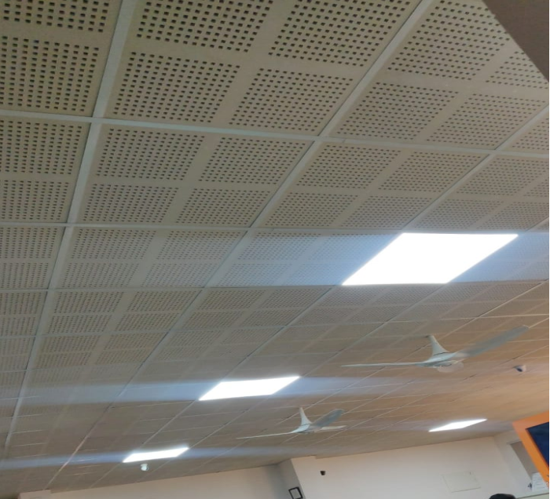  LED bulbs | 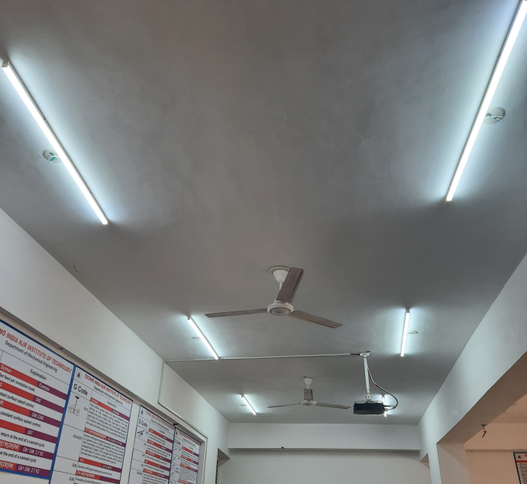  LED tube lights

