# Facilities for the Management of Degradable and Non-degradable Waste in Techno India NJR Institute of Technology

# Solid Waste Management

This Institute has to ensure that all the campus wastes are disposed of responsibly by using proper waste segregation mechanism at the source and, if possible, converting it into a value-added environmentally friendly product.

The Campus has adopted the principles of the ‘best practicable environmental option’ to deliver its waste management services. The Campus applies a ‘waste hierarchical approach’ to reduce, reuse, recycle, and recover waste products in preference to waste disposal to landfill. Figure 1 shows a schematic diagram of solid waste management of the Campus.

Waste Generation

Waste handing, separation, storage, processing at the source

Vermicomposting for Biodegradable Waste

Collection

Two trolleys and one pick up are available for the waste transportation

Transfer and transport

Separation and processing and transformation solid waste

Plastic waste for using research in building materials

Disposal

E - Waste Hazardous Waste to municipal co. of Udaipur

# Figure 1: Interrelationships between the functional elements in Solid Waste Management in Campus

* Waste Segregation: Source segregation via separate bins as per the waste. Following color code is used for different types of wastage.
* Green Bins: For biodegradable waste
* Blue Bins: For plastics waste
* Red Bins: Hazardous and Sanitary waste
* Black Bins: For E-Waste
* Dimensions and 3d views of the collection and processing center on the college campus are shown in Figures 2 and 3.

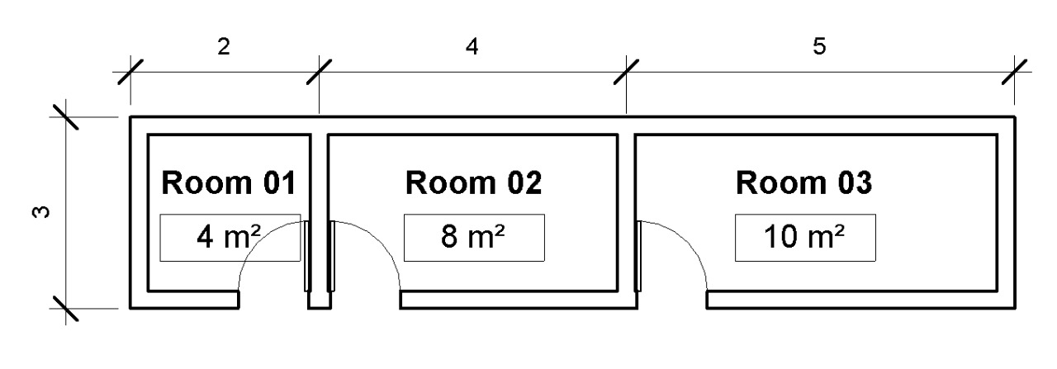

**Figure 2: Area and Dimensions of Processing Center (Outer Dimensions in meter)**

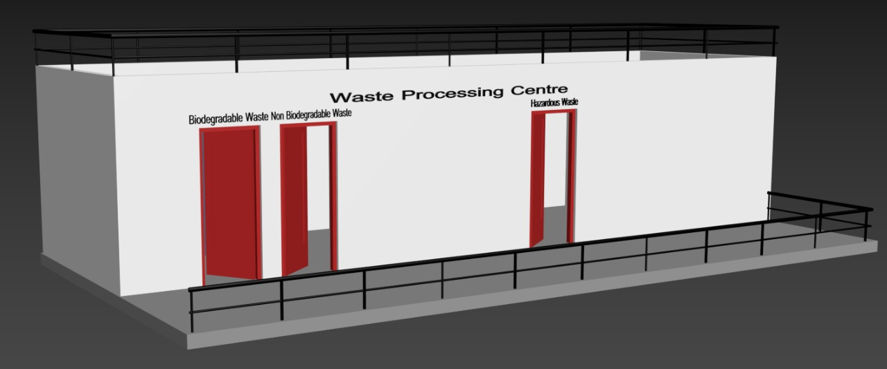

**Figure 3: Processing Center for Waste at the Campus**

# Management Staff

# Supervisor for the supervision of supporting staff.

* Supporting staffs will be responsible for

1. Cleaning and separate the waste from each facility
2. Collection of separated waste from different colored bins
3. Transport all waste to the collection center of Campus
4. Support all recycling processing activities

* Resources for Waste management:

There are 30 dust bins of different color for collection of solid waste. There is also a garbage collection center for separated waste in the campus. Figure 4 shows geotagged photographs of the facilities.

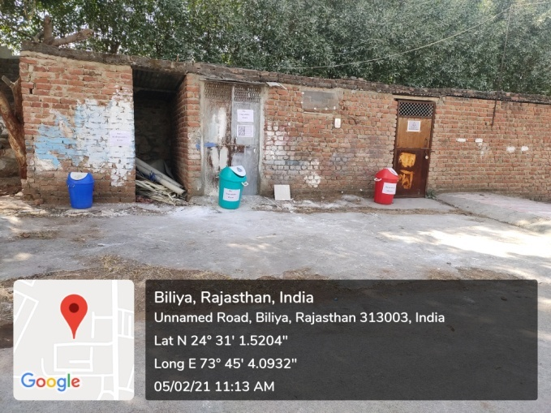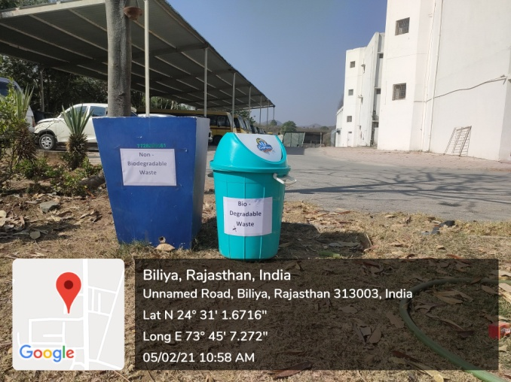

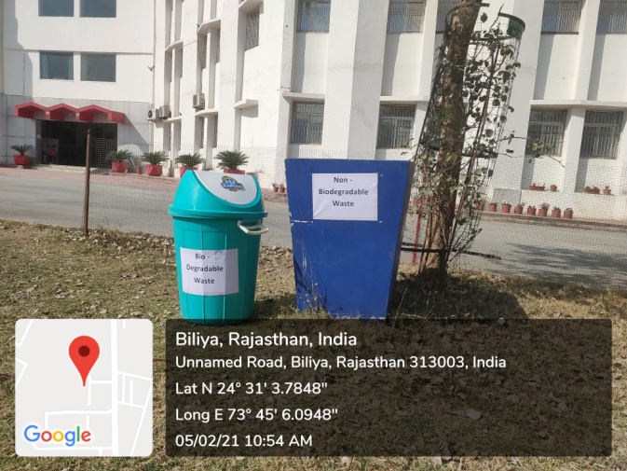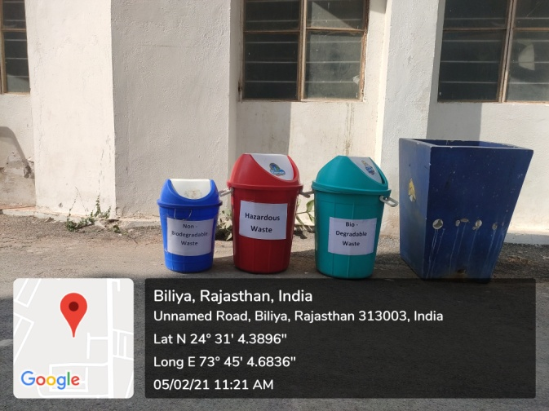

**Figure 4: Geotagged Photographs of the Waste Management facilities in the Campus of Techno India NJR Institute of Technology, Udaipur**

1. **Liquid Waste Management**:

Wastewater management options and technologies can be functionally divided into two segments. Firstly, septic tanks are used for sewage waste water. Secondly, wastewater from bathrooms is treated through coagulants for the separation of soap and other suspended particles, and this treated water is used for gardening.

1. **Biomedical and Radioactive Waste Management:**

There is no biomedical and radioactive waste generated in the campus.

1. **Hazardous Chemicals Waste Management:**

There are separate red colored bins and room (shown in figure 4) for sanitary and hazardous waste. These types of wastes are disposed on Municipality landfill site outside city.