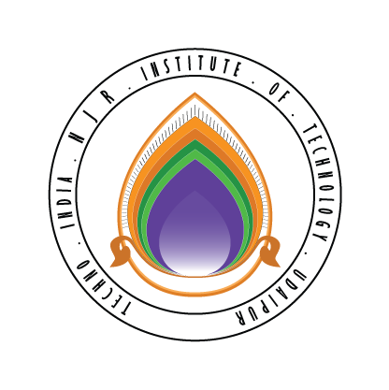 | Techno India NJR Institute of Technology  Bhamashah (RIICO) Industrial Area, Kaladwas, Udaipur

Date: 15/04/2020

Salesforce Training

Salesforce training will be conducted from 20th April 2020 (Monday). The following students will attend this training. The training will be conducted by Mr. Pankaj Chittora. The class timing will be from 12:00 noon to 1:00 pm.

1 | Anuj Sharma
2 | Apoorva Jindal
3 | Ashi Kothari
4 | Bhavit Kanthalia
5 | Charul Singhvi
6 | Devyani Gupta
7 | Dheeraj Dashora
8 | Jinisha Jain
9 | M Sajid Mansoori
10 | Mahima Kothari
11 | Mahima Sharma
12 | Mohammed Afzal Raza
13 | Nikita Jain
14 | Nikita Pande
15 | Priyanshu Choudhary
16 | Rahul Suthar
17 | Ratiksha Khatik
18 | Roopin Kothari
19 | Ruchika Purohit
20 | Sakshi Madrecha
21 | Subhash Meghwal
22 | Swati Devpura
23 | Tanishka Jain
24 | Virendra Singh
25 | Yash Malasiya

Gaurav Kumawat
(Department Coordinator)

