TechJalsa is the inter university fest of our college being organised based on different different themes every year and it’s going to be much more higher level inviting 150+ engineering colleges and expecting a footfall of about 2000-3000 students.

8 sections are to covered in this fest >Technical >Cultural >Online >Literary >Arts >Gaming >Photography >Roadies

TechJalsa 2K16 (19th March – 23rd March 2016)

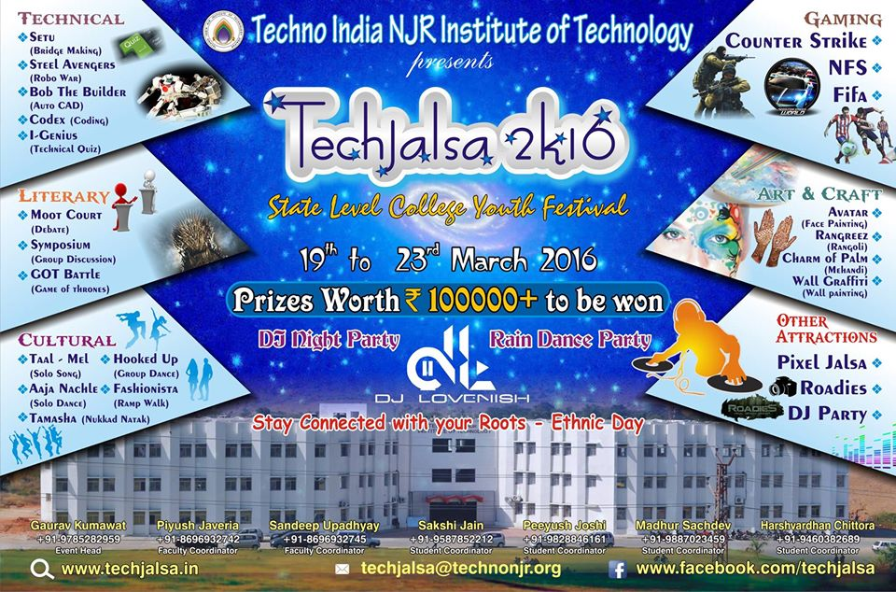

TechJalsa 2K17 (9th March – 12th March 2017)
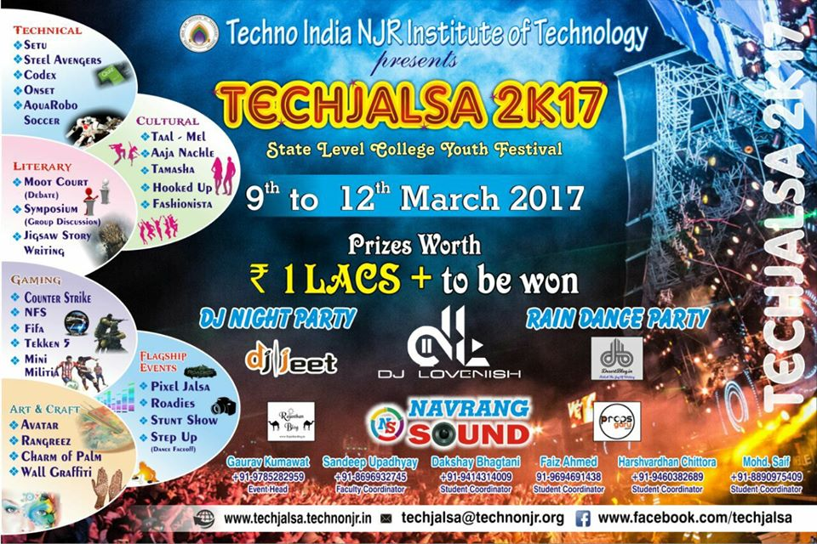

TechJalsa 2K18 (25th February – 27th February, 2018)
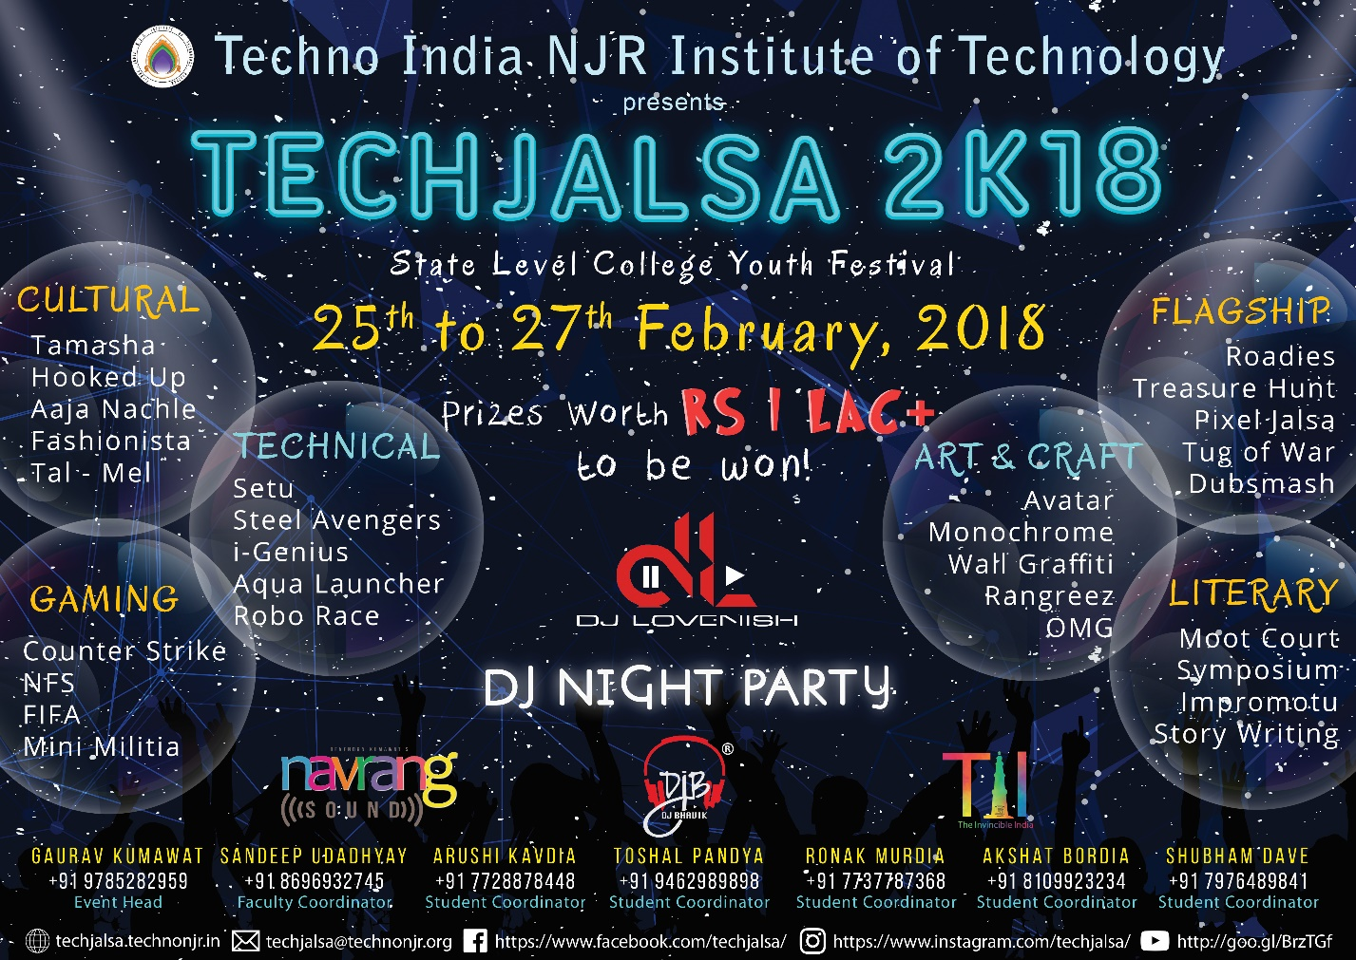

TechJalsa 2K19 (8th January – 11th January, 2019)
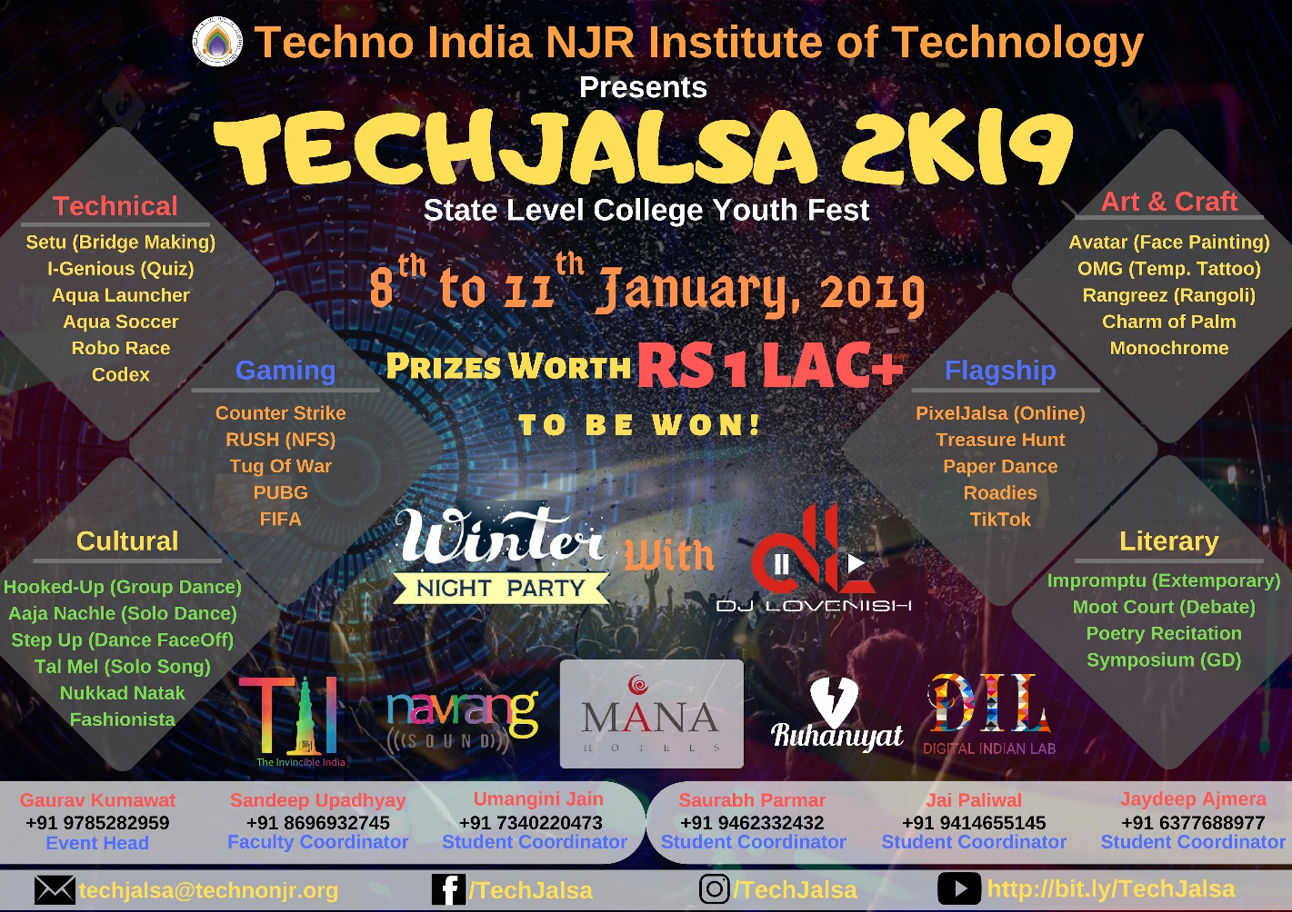

Freshers party
The word fresher's party itself points towards Fresher's i.e. the event organised for freshers.
This event is organised by Senior students to have a good communication with the juniors and to welcome the juniors in their college. This event will have a full day party program in the campus or some auditorium. Juniors performs the ramp walk and show their talents. Some performance by senior students also. At the end of the party Judges will give the tag of Mr. Fresher and Mrs. Fresher to the best performer of the day.
Juniors should take advantage from this event. They should show their talents and get a good communication with their seniors because the seniors are the person who will only help you in the future mainly at the time of examination or selection of carrier in the future.
Phoenix 2016 (5th November 2016)
Fresher Party (Phoenix 2016) was organized on Saturday for first year students at Techno India N. J. R. Institute of Technology. During this period, many students gave exciting performances of ramp walk, dance, anthem etc.
Miss and Mr. Fresher had rounds of catwalks, talent rounds, quizzes, etc. to choose from, in which Hrithik Vaishnav was selected as Mr. Fresher and Rashmi Sharma as Miss Fresher. Runner up were Murtaja Chunawala and Kajol Parihar.
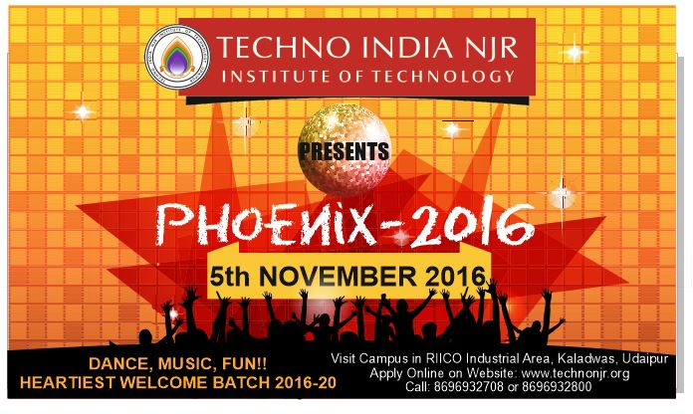

Phoenix 2017 (28th February 2018)
Fresher Party (Phoenix 2018) was organized on Wednesday for first year students at Techno India N. J. R. Institute of Technology. During this period, many students gave exciting performances of ramp walk, dance, anthem etc.
Miss and Mr. Fresher had rounds of catwalks, talent rounds, quizzes, etc. to choose from, in which Tushar Choudhary was selected as Mr. Fresher and Nimisha Sharma as Miss Fresher. Runner up were Rahil and Arpita Kothari.
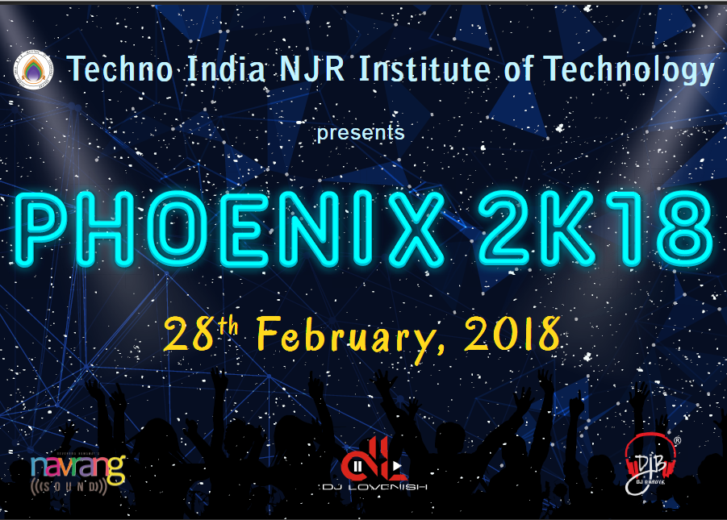

Phoenix 2018 (12th January 2019)
Fresher Party (Phoenix 2019) was organized on Saturday for first year students at Techno India N. J. R. Institute of Technology. During this period, many students gave exciting performances of ramp walk, dance, anthem etc.
Miss and Mr. Fresher had rounds of catwalks, talent rounds, quizzes, etc. to choose from, in which Kavya Ameta was selected as Mr. Fresher and Tejaswini Mehta as Miss Fresher. Runner up were surabhi singh and Chirah Paliwal.
Chief Guest Lalit Yagnik, Managing Director RS Vyas and Meera Ranaut, Principal Pankaj Porwal gave prizes to the winners.
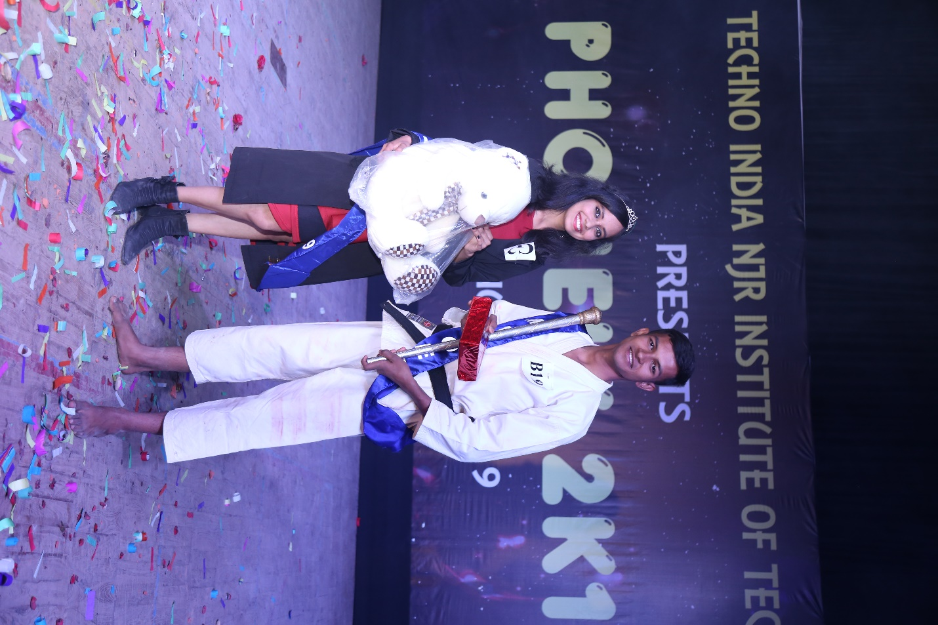
Phoenix 2019 (3rd January 2020)
A fresher party (Phoenix 2019) was organized for first-year students at the Techno India N. J. R. Institute of Technology on Sunday. During this event, many students gave exciting presentations of ramp walk, dance, anthem etc.

Miss and Mr. Fresher had rounds of catwalks, talent rounds, quizzes, etc. to choose from, in which Geethanshu Kalal and Shivansh Suthar were chosen as Mr. Fresher and Tanu Sharma as Miss Fresher. The Runner up were shreya and deeksha bapna.
Along with this, cash prizes were awarded to those who got the best marks from all the branches every year. The guests distributed prizes to the winners.

