CURRICULUM VITAE

Hitkaran Singh Ranawat
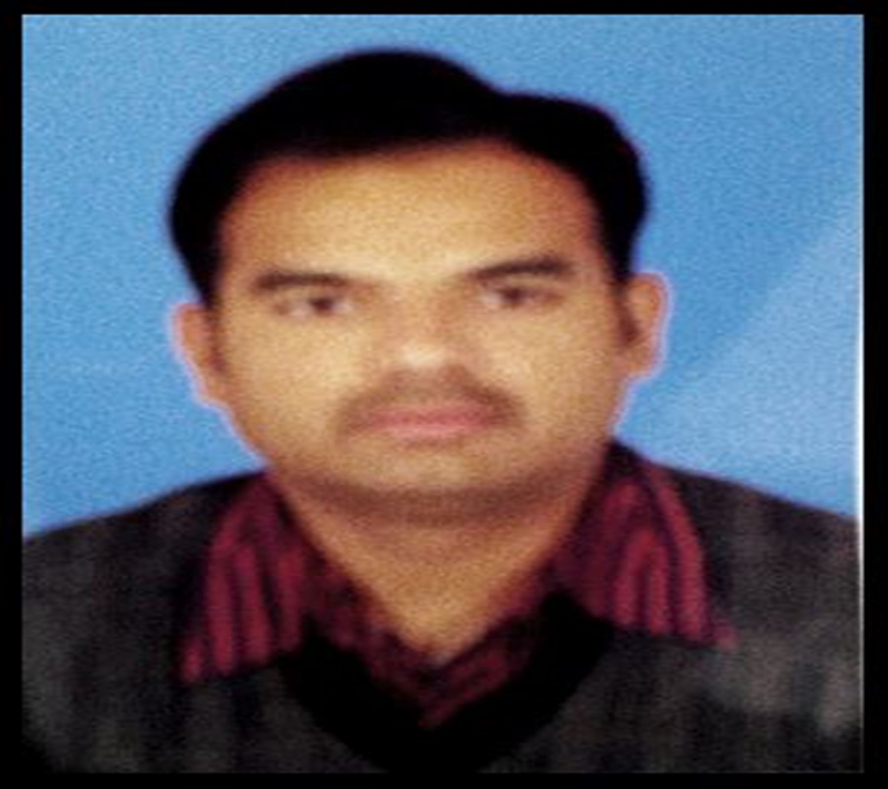

Current Location : - Udaipur

Contact No : - 9509311813
E-mail : - hit_ranawat@yahoo.co.in
Address : - 3-Jha-27, Prabhat Nagar, Hiran Magri,
Sec.No.5, Udaipur

Career Objectives:-
To establish myself in the field of education, to utilize my skills and experiences to help students to achieve high targets in their academic.

Academics:-

- 2017 : Pursuing Ph.D. from B.N University, Udaipur
Topic : A Critical Study on Changing Values in modern times with special reference to Chetan Bhagat’s novels.

- 2012 : Bachelors of Education ( B.Ed. ) from Pacific University, Udaipur.
Subjects : English and Civics.
Division : First

- 2007 : Masters of Philosophy ( M.Phil. ) from J.R.N.V U, Udaipur.
Subjects : English Literature
Division : First

- 2006 : Masters of Arts ( M.A. ) from J.R.N.V U, Udaipur.
Subjects : English Literature
Division : First

- 2004 : Bachelors of Arts (B.A.) from M.L.S.U, Udaipur.
Subjects : English Literature, Political Science & Public Administration
Division : Second

Professional Qualification:-

- One Year Diploma in GUIDANCE AND COUNSELING with 1st division.
- One Year Honors Diploma in WEB-CENTRIC COMPUTING from NIIT with 69%.

Relevant Experience:-

2018-20 – Asst. Professor (English)
Techno India NJR Institute of Technology
2018 – Asst. Professor (English)
Aravali Institutes of Technical Studies (AITS)

2015-17 – Guest Faculty (English)
College of Technology and Agriculture Engineering (CTAE)
- In charge of Language Lab.
- Lectured Technical Writing paper to the first year M. Tech. and PhD students.

2012-15 – Asst. Professor (English)
Geetanjali Institutes of Technical Studies (GITS), Udaipur
- In charge of discipline committee.
- Build a good environment to promote fairness and respect.

2010-11 – Faculty (English)
Directorate of Students’ Welfare (Maharana Pratap University of Agriculture and Technology)
- Monitoring students’ learning.
- Increased students’ English language and overall personality.

2009-10 - Asst. Professor (English)
Pacific College, Udaipur
- Prepared students’ for group discussions and interviews.

2006-09 - Visiting Faculty (English)
At The Pacific College & at the Department of Computer and I.T (J.R.N.V.U),Udaipur.

Conferences &Workshops Attended:-
- Participated 3-Day Teacher Training Workshop on “Induction Programme” organised By RTU, Kota under TEQIP-III RTU (ATU) Project at SKIT, Jaipur.
- Participated Two Week Faculty Development Program “FDP 2017-18 for PROMOTION OF ENTREPRENEURSHIP AMONGST STUDENTS” organised by the Entrepreneurship Development Cell, MLSU, Udaipur.
- “National Symposium Indo-Canadian concerns: Towards Building up a Cultural Bridge” organized by the Department of English MVS College, JRN Rajasthan Vidyapeeth, Udaipur, in collaboration with Indian Association for Canadian Studies during 27-28 May,2011
- International Conference ESL-EFL and VI Annual Conference of R.A.S.E organized by M.V.Sharamjeevi College on 5th, 6th & 7th November 2009.
- National level Conference of Rajasthan Association for Studies in English on 18-19 November 2007, Govt. P.G.College, Pratapgrah (Raj.
- National Seminar On “Revisiting The Classics: Text, Context And (Re)Interpretation” at Nirma University, Ahmedabad .

Awards & Achievements:-
- Appreciation a best faculty of Basic Science Dept. on the basis of student’s feedback.
- Certificate of Participation IV Annual Conference of R.A.S.E (Rajasthan Association for Studies in English).
- Certificate in course entitled SWIFT INDIA + SWIFT NET SURF from NIIT, Udaipur.
- Certificate of INTERNATIONAL ENGLISH LANGUAGE TESTING SYSTEM.
- Certificate of Participation in National Seminar on the Topic Masses, Market and Literature.
- Certificate of District Level Sports Competition 2000-01.

Academic work:-
In addition to teaching I have executed the following additional duties:-
- Coordinated the fest ‘FESTAZAR 2013’ of GITS.
- Worked as In-charge of Examination & Discipline Committee at Pacific College.
- Edited the Magazine ‘ZEAL 2010’ of Pacific College.

Invited:-

- As an External Examiner for the practical examination of RTU at Aravali Institute of Technical Studies (A.I.T.S)
- As an External Examiner for the practical examination of English at College of Technical and Agriculture Engineering (C.T.A.E)
- As an External Examiner for the practical examination of RTU at Maharaja College Of Engineering, Udaipur.

Extra Curricular Activities:-
- Worked as discipline incharge.
- Managed cultural fest of college.
- Worked as a member of Magazine Committee.
- Worked as a faculty advisor.

Soft Skills:-
- Good team player
- Aware of human values.
- Excellent communication.
- Hardworking, self motivated, excellent written & oral communications skills, quick-learner, team-player, able to adopt new work environment & situations, posses responsible leadership qualities.

Computer Proficiency:-

PACKAGE ( M.S OFFICE ) : - M.S WORD 2007, M.S EXCEL 2007, M.S POWER POINT 2007.
DATABASE : - SQL SERVER 7.0
LANGUAGE : - C ++, JAVA, HTML, UML
OPERATING SYSTEM : - WINDOW NT SERVER 4.0, LINUX, UNIX, WINDOW 98

Assignments:-
- Presented the paper entitled Revisiting the Greek Tragedy as “A Classic on its own” at Nirma University that organizes national seminar on revisiting the classics: text, context and (re)interpretation.
- Presented the paper entitled “Translation: - Theory and Practice (An Experiment with the Short Story ‘CHIUNTI’)” which was submitted for the partial fulfillment of Master of Philosophy in English Literature. It discusses the problems of translation faced while translating the short story.
Main Objectives of the paper are:
- To expose general ideas on the problems of Translation.
- To impart information on the various types of translation.
- To describe translation in its proper perspective.
- To identify the status of translation and the role of the translator.

- Presented a project on the management of the college at the time of Diploma course using SQL, Linux and Window NT Server.
Main Objectives of the Paper are:
- To provide information related with the admission forms and fees of the college.
- To inform about the admission procedure of the college.
- Compelled to fill correct information in the form.

Languages Known:-
. Hindi . English . Spanish

Hobbies:-
. Travelling . Talking Myself . Surfing Internet

Personal Details:-
- Father’s Name : - Shri. Ganshyam Singh Ranawat
- Marital Status : - Married
- Date of Birth : - 25.06.1982

