SUMMARY 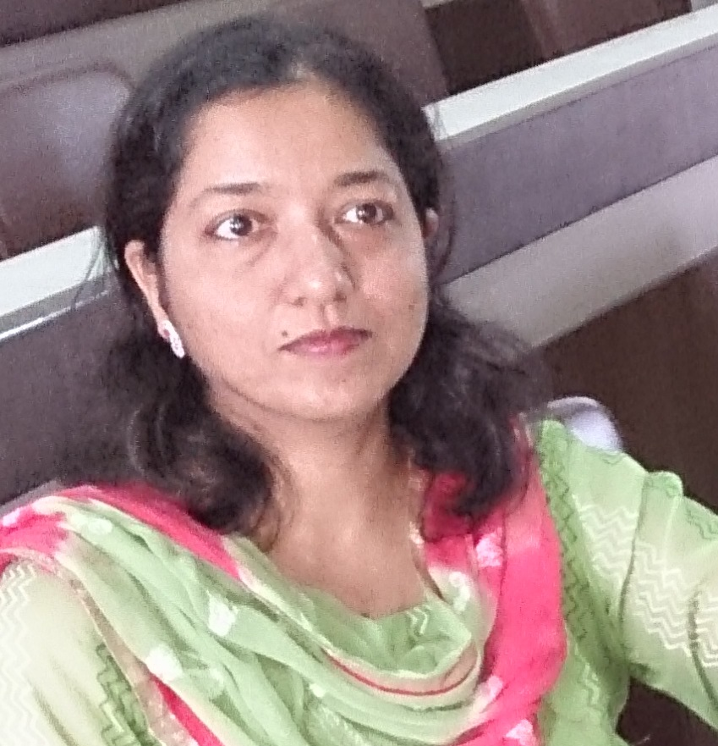

Dr. Yasmin is a Ph.D. and has cleared National Eligibility Test (NET,UGC- CSIR) for lectureship in the year 2001 and has 16 years of teaching as well as research experience. Has proven leadership qualities and get well along with people.
The Mohan Lal Sukhadia University had approved her as faculty member in engineering faculty for a term upto17th May,2005 to 4th Jan.,2007.
OBJECTIVE:
To be successful and efficient person in the globally competitive environment and add values to both to the organization and my self and be a contributor to the development of nation by guiding and helping students to improve their knowledge and skills.
Awards:
- Awarded Best Faculty in Senior Category by Techno India NJR Institute of Technology, Udaipur in the Year 2013.
- Awarded by Bohra community (women) for getting Ph.D. degree in 2000.
- J.C.W. Rust Award for Chess.

Research Supervisor: Approved as a recognized supervisor of PAHER University for guiding doctoral research / master’s course in the faculty of science.
No. of Students Enrolled: 2
Degree Awarded: 1

Research Experience
Completely involved in research work from August 1997 to 2000. The work dealt with the wastewater treatment. The reagent named as photo-Fenton’s reagent was devised and was found to be better than Fenton’s reagent for degradation of organic pollutants.

Research Topic:
“Use of Fenton’s, Photo-Fenton’s and Other Related Reagents: A Comparative Study.”
Research Guide: Prof. S. C. Ameta

Publications:
1.Published 7books for first year B.Tech engineering and chapters in 2 international books.

(1) Solar Energy Conversion and Storage: Photochemical Modes, Editors: Suresh C. Ameta and Rakshit Ameta, Chapter:7 Photogalvanic Cells by Yasmin, Abhilasha Jain, P.B. Punjabi and Suresh C. Ameta. CRC Press, Taylor and Francis Group. ISBN 9781482246308 - CAT# K23582, 2015
(2) Green Chemistry Fundamentals and Applications: Chapter-12,Green
Composites by Dr.yasmin.ISBN:978-1-926895-43-7 Apple Academic
Press, Toronto, New Jersey, CRC PRESS. 2014
(3) Engineering Chemistry by Suresh ameta,Yasmin,Shipra bharadwaj,Chetna
kumarI,Kiran durgawat.ISBN978-81-7906-152-7,HimanshuPublications,
Udaipur
(4) Practical engineering chemistry by Suresh ameta,Yasmin, Shipra
Bharadwaj, Chetna gomber, Ritu vyas, Himanshu Publications, Udaipur.
(5) Engineering Chemistry-I by Suresh ameta, Yasmin,Shipra bharadwaj,
Chetna gomber,Kiran durgawat. Himanshu Publications, Udaipur.
(6) Engineering Chemistry-II by Suresh ameta, Yasmin,Shipra
bharadwaj,Chetna Gomber,Kiran durgawati. ISBN 978-81-7906-21-6,
Himanshu Publications, Udaipur.
(7) Environmental Engineering and disaster management by
Gaur,Joshi,,Chippa,Jain, Yasmin. ISBN 978-81-8182-482-0, RBD
Professional Publications, Jaipur.
(8) Environmental Engineering by Joshi,Jain,Sharma,Chippa,Yasmin.
ISBN 81-8142-382-8, Ramesh Book Depot, Jaipur
(9) Practical Environmental Engineering Joshi,Jain,Sharma,Chippa,Yasmin.
ISBN 81-8142-381-X, Ramesh Book Depot,Jaipur.

2. (i) Paper published in International Journal of Computer Applications Proceedings on National Conference on Advances in Technology and Applied Sciences. NCATAS - Number 1.Year of Publication: 2014, Authors: Yasmin and Aditi Ameta. Comparative Study of Degradation of Two Azo Dyes by Photo-Fenton Process. pp.5-8, ISSN No. 09758887, peer reviewed journal, impact factor: 0.715
(ii) Paper published in Int. J. Chem.Sci. pp.1277-1285, Paper No. IJCS/13/1866 Degradation and decolouration of Amaranth dye by the Photo-Fenton’s and Fenton’s reagents- A comparative study. Yasmin Ali and Aditi Ameta., ISSN No. 0972768X, peer reviewed journal, impact factor: 0.12.

(iii) Paper published in Int. J. Chem. Sci.:Vol.11(1), 2013, p.p.383-389.”Typha domingensis: A New Hope for Waste Water Treatment”.
Chetna Gomber, Sunita Parihar,Yasmin and Ganpat Choudhary. ISSN No.0972768X, peer reviewed journal, impact factor: 0.12.

(iv) Paper published in national journal, J. Indian Chem. Soc., vol.83, January 2006, pp.42- 48. “ A comparative study of Fenton’s, photo-Fenton’s and other related reagents: resorcinol- TiO₂ system. “
Suresh C. Ameta, P.B. Punjabi, Chetna Kumari and Yasmin. ISSN No.00194522, Impact factor: 0.34(2006).

Conference / symposium:
(1 ) Presented paper in International Conference on Advances in Technology and Applied Sciences. NCATAS-2014, 28-29 March, 2014. JIET School of Engineering and Technology for Girls, Jodhpur. and Oil India Limited. “Comparative Study of Degradation of Azo Dyes by Photo-Fenton Process.”
(2) Participated in two days ISTE workshop on Research Methods in Educational Technology conducted by IIT, Bombay on 2nd and 9th February, 2013.
(3) Participated in two days ISTE workshop on Aakash for Education conducted by IIT, Bombay on 10th and 11th November,2012.
(4) Participated in two week ISTE workshop on Introduction to Research Methodologies conducted by IIT Bombay from 25th June to 4th July, 2012.
(5) Presented paper in International Conference on Global Trends in Pure and Applied Chemical Sciences under the auspices of Asian Journal Of Chemistry on 3-4 March 2012, Udaipur, INDIA.
(6) Presented paper in poster session in national Conference on Chemical Sciences in New Millennium on 8th January,2012. Dept. of Chemistry, Pacific College of Basic and Applied Sciences.
(7) Participated in two days ISTE workshop on Writing Effective Conference Papers conducted by Indian Institute of Technology, Bombay on 18th and 19th February, 2011.
(8) Participated in two week ISTE workshop on Software Development Techniques for Teachers of Engineering and Science Institutes conducted by Indian Institute of Technology, Bombay from 5th Nov. to 4th December, 2011.
(9) Presented poster in 15th international conference of Indian Society of Chemists and Biologists, organized by Dept. of Chemistry Saurashtra University, Rajkot on 4th to 7th Feb.2011
(10) Attended India international rubber conference & expo -2007 on “Recent advances in rubber science & allied material technology”
Organized by J.K.Tyre & MLS University, Udaipur, Rajasthan on 1st -3rd November 2007.
(11) Attended national symposium on “Photo catalysis for energy, environment and chemical industries” organized by Department of Chemistry, MLSU, Udaipur on 14th&15th December, 2005.
(12) Participated in a symposium sponsored by U.G.C. on the topic” Recent trends in chemical sciences” organized by Department of Chemistry, Sukhadia University, Udaipur (RAJ.) on 28th Dec. to 30th Dec.2000.

Work Information / Experience: 16 years

Present Employer: Techno India NJR Institute of Technology, Udaipur (RAJ.)

Designation: HOD and professor, Department of Chemistry

Duration: 19th SEPTEMBER, 2008 to till date
Team Member Of:
- Techno NJR Discipline committee
- GITS Newsletter
- Research and publications
- Academic and cultural activities
- Counseling and career guidance
Past Experiences:
- Associate Professor in Geetanjali institute of technical studies, udaipur in the year 2003 to 7th October 2008, teaching engineering chemistry to B.Tech students.
- Lecturer (Guest faculty) in Vidya Bhawan Rural Institute, Udaipur in the year 2002-2003, teaching physical chemistry to post-graduate students.
- Lecturer (Guest faculty) in C.T.A.E., Udaipur in the year 1999 to 2001, teaching engineering chemistry to undergraduate students.
- Lecturer (Adhoc) in B.N.P.G. College, Udaipur in the year 2000-2001, teaching organic and inorganic chemistry to post graduate and under-graduate students.
- Research Scholar in Science College, Udaipur in the year 1998-1999, and teaching physical chemistry to B.Sc. students.

Education
- Cleared NET(UGC-CSIR) exam in 2001, in chemical sciences
- Awarded doctorate in photo-chemistry in 2000 by MLSU, Udaipur..
- Post Graduate in organic chemistry from Mohan Lal Sukhadia University, Udaipur in 1996 with 60.58%.
- Graduated from Mohan Lal Sukhadia University,Udaipur in 1994 with 63.85%.
- Cleared senior secondary exams, RBSE, Ajmer in 1991 with 59.6% .
- Cleared secondary exams, RBSE, Ajmer in 1989 with 70.91%.

Knowledge of:
- Modern and conventional wastewater treatments methods.

Computer Skills:
Operating Systems: Windows , LINUX and Internet Basics.

Personal Details

Permanent Address: 58, Najam Marg
Bohrawadi,
Udaipur – 313001
(Rajasthan)

Date of Birth: 20th August 1974

Phone: 9829199963 (Mobile)
(0294) 2417994 (Res.)

E-mail: ali_yasmin2002@yahoo.com

