Network, Hardware
&
Software Configuration Specification

TECHNO INDIA NJR INSTITUTE OF TECHNOLOGY
Department of Computer Science & Engineering
AND
Department of Information Technology

Existing Network Configuration with Description
S.No | Name of Equipments | Quantity | Specifications
 | Tech routes 1725 router | 01 | CPU | Motorola MPC860T 50MHz | 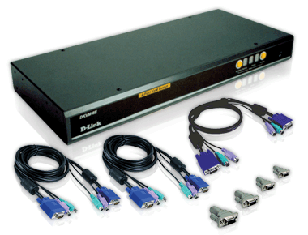
 | Tech routes 1725 router | 01 | Flash | 32MB
 | Tech routes 1725 router | 01 | Memory | SDRAM 64MB
 | Tech routes 1725 router | 01 | EPROM | 512K
 | Tech routes 1725 router | 01 | Interface | 1 console port  2 10/100M Fast Ethernet Port  1 CE1 Port
 | Tech routes 1725 router | 01 | Dimensions (L x W x H) | 445mm x 310mm x 45mm
 | Sophos XG firewall | 01 | Type | VPN Firewall | 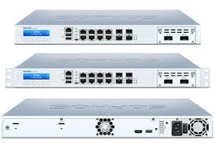
 | Sophos XG firewall | 01 | Form Factor | Standalone
 | Sophos XG firewall | 01 | Brand | Sophos
 | Sophos XG firewall | 01 | Model | XG210
 | Sophos XG firewall | 01 | MPN | APL19-05C
 | Sophos XG firewall | 01 | Connectivity | Wired - Ethernet (RJ-45)
 | Sophos XG firewall | 01 | Number of LAN Ports | 08
 | Sophos XG firewall | 01 | Number of WAN Ports | 4
 | D-link DES 1226G | 01 | Description | DES-1226G Web Smart (24) Ports 10/100Mbps with 2 combo copper gigabit/SFP ports | 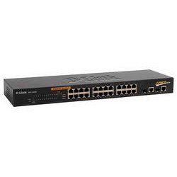
 | D-link DES 1226G | 01 | MAC Address Table | 6K
 | D-link DES 1226G | 01 | Switch Fabric | 8.8Gbps
 | D-link DES 1226G | 01 | Transmission Method | Store-and-forward
 | D-link DES 1226G | 01 | Diagnostic LEDs | Per Unit: Power  Per Port: Activity/Link & Speed
 | D-link DES 1226G | 01 | Packet Buffer Memory | 512KB
 | D-link DES 1226G | 01 | Max Power Consumption | 16 Watts
 | Cisco catalyst switch 2690 | 01 | 24 ports of Gigabit Ethernet desktop connectivity with two 10 Gigabit Ethernet SFP+ Uplinks |  | 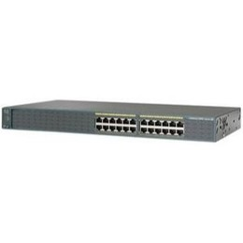
 | Cisco catalyst switch 2690 | 01 | Industry first PoE+ with up to 30W per port
 | Cisco catalyst switch 2690 | 01 | Cisco FlexStack stacking module with 40 Gbps of throughput, allowing ease of operation with single configuration and simplified switch  upgrade
 | Cisco catalyst switch 2690 | 01 | Catalyst Smart Operations allows for zero touch deployment
 | Cisco catalyst switch 2690 | 01 | Cisco Auto Smartports enables automatic configuration by connected device type
 | Cisco catalyst switch 2690 | 01 | Superior Layer 2 threat defense capabilities
 | Cisco catalyst switch 2690 | 01 | Enhanced Cisco EnergyWise to measure, report and reduce energy usage across the entire organization
 | Cisco catalyst switch 2690 | 01 | Supports Virtual Area Network
 | D-link Switch DFS1224D | 01 | MAC Address Table Size | 8K | 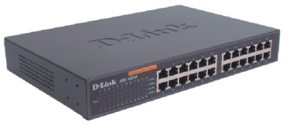
 | D-link Switch DFS1224D | 01 | Switch Fabric | 48Gbps Forwarding Capacity
 | D-link Switch DFS1224D | 01 | Transmission Method | Store-and-Forward
 | D-link Switch DFS1224D | 01 | Diagnostic LEDs | Per Unit: Power  Per Port: Activity/Link, Speed
 | D-link Switch DFS1224D | 01 | Packet Buffer Memory | On ship: 512KBytes Buffer Memory per Device
 | D-link Switch DFS1224D | 01 | Max Power Consumption | 19.1 Watts
 | D-link Switch DFS1224D | 01 | QoS | 802.1p (4 Queues)
 | D-link Switch DFS1224D | 01 | Total Ports | 24
 | D-link Switch DFS1224D | 01 | Interface RJ-45 | 10/BASE-T, 100BASE-TX, and 1000BASE-T
 | D-link Switch DFS1224D | 01 | Description | 24-Port Gigabit Switch, Desktop/Rackmountable, D-Link Green
 | IBM Blade center | 01 | Form factor/height | Rack mount chassis/9U | 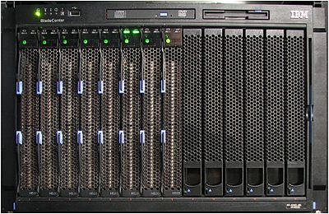
 | IBM Blade center | 01 | Blade bays | Up to 14
 | IBM Blade center | 01 | Interface | GUI/ CLI
 | IBM Blade center | 01 | Features | VLAN, Port Filtering, Line Aggregation, , Port Trunks, Remote Monitoring
 | IBM Blade center | 01 | Internal Ports | 14full duplex gigabit ports  02 internal 100 Mbps ports
 | IBM Blade center | 01 | External Ports | 06 10/100/1000 Mbps interface
 | IBM Blade center | 01 | Light path diagnostics | Blade server, processor, memory, power supplies, blowers, switch module, management module, internal storage and expansion card
 | IBM Blade center | 01 | Application Service | MERCE (License Expired in April 2012)
 | IBM application server | 01 | Processor | Four-core Intel ® Xeon E5620 2.40 GHz with 12 MB of cache per processor socket standard or six-core Intel Xeon X5675 3.06 GHz with 12 MB of cache per processor socket (configure to order only) | 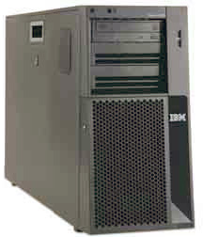
 | IBM application server | 01 | Memory | 16 DIMM slots maximum, 128 GB with DDR-3 1333 MHz RDIMMs or 48 GB with DDR-3 1333 MHz UDIMMs
 | IBM application server | 01 | Expansion slots | Five PCIe and 1 PCI standard; additional 2 PCI-X or 1 PCIe
 | IBM application server | 01 | Disk bays | Standard with four 3.5" simple-swap Serial ATA (SATA) or four 3.5" hot-swap SATA/Serial Attached SCSI (SAS) HDDs or eight or sixteen 2.5" hot-swap SAS/SATA HDDs. Eight 3.5" hot-swap SAS/SATA HDDs1
 | IBM application server | 01 | Network interface | Integrated dual Gigabit Ethernet
 | IBM application server | 01 | RAID support | Integrated 6 Gbps or 3 Gbps RAID-0, -1, -1E (model dependent), optional RAID-10, -5, -50, -6, -60
 | IBM application server | 01 | Systems management | Integrated systems management processor
 | Hp Server  HP Pro 3090 MT | 01 | Model | HP PRO 3090 Microtower PC | 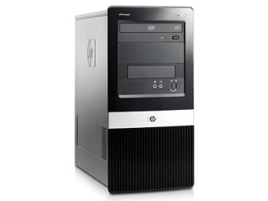
 | Hp Server  HP Pro 3090 MT | 01 | Processor | Intel (R) Core (TM) 2 DuoCPU E7500 @2.93 GHz
 | Hp Server  HP Pro 3090 MT | 01 | OS | Windows XP Professional (5.1) Service Pack 3
 | Hp Server  HP Pro 3090 MT | 01 | RAM | 2 GB RAM
 | Hp Server  HP Pro 3090 MT | 01 | Hard Disk | 360 GB HDD
 | Hp Server  HP Pro 3090 MT | 01 | Monitor | HPL 1506 TFT Monitor
 | Hp Xeon Server | 01 | Model | ProLiant ML10 | 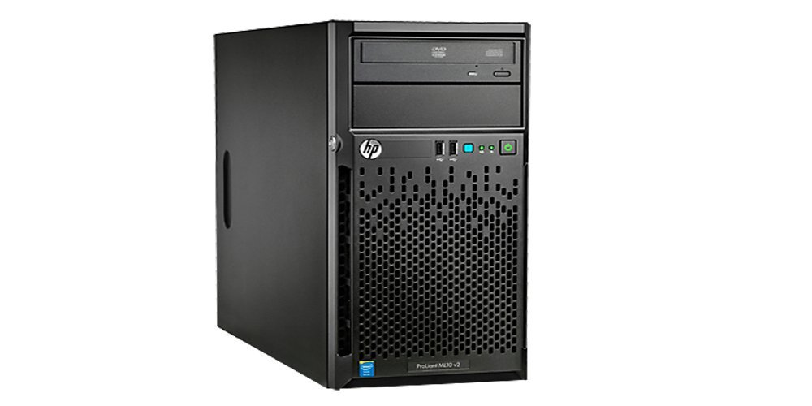
 | Hp Xeon Server | 01 | Processor | Xeon
 | Hp Xeon Server | 01 | OS | Windows 10, Ubuntu 16.04
 | Hp Xeon Server | 01 | RAM | 16 GB RAM
 | Hp Xeon Server | 01 | Hard Disk | 1 TB HDD
 | Hp Xeon Server | 01 | Monitor | HP 22-inch TFT Monitor
 | Hp Xeon Server ProLiant | 02 | Model | HP ProLiant ML110 G4 Tower Server 432535-035 | 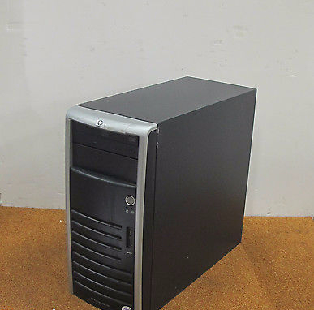
 | Hp Xeon Server ProLiant | 02 | Processor | Xeon 3040 1.86GHz
 | Hp Xeon Server ProLiant | 02 | OS | Windows 7, Ubuntu 16.04
 | Hp Xeon Server ProLiant | 02 | RAM | 4 GB RAM
 | Hp Xeon Server ProLiant | 02 | Hard Disk | 1 TB HDD
 | Hp Xeon Server ProLiant | 02 | Monitor | HP 18.5 TFT Monitor
 | D-Link Wi-Fi  DWL-2100AP | 25 | Service Pack SP1 v.275 |  | 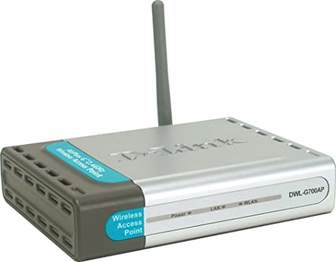
 | D-Link Wi-Fi  DWL-2100AP | 25 | 2.4GHz Processor
 | D-Link Wi-Fi  DWL-2100AP | 25 | WPA & 802.1x Authentication
 | D-Link Wi-Fi  DWL-2100AP | 25 | SNMP Management Software Included
 | D-Link Wi-Fi  DWL-2100AP | 25 | Also Works as Point-To-Point Bridge, Point-to-Multipoint Bridge, Repeater, Wireless Client
 | TP link Wi-Fi | 01 | TP-Link 2.4GHz 300Mbps 12dBi Outdoor CPE |  | 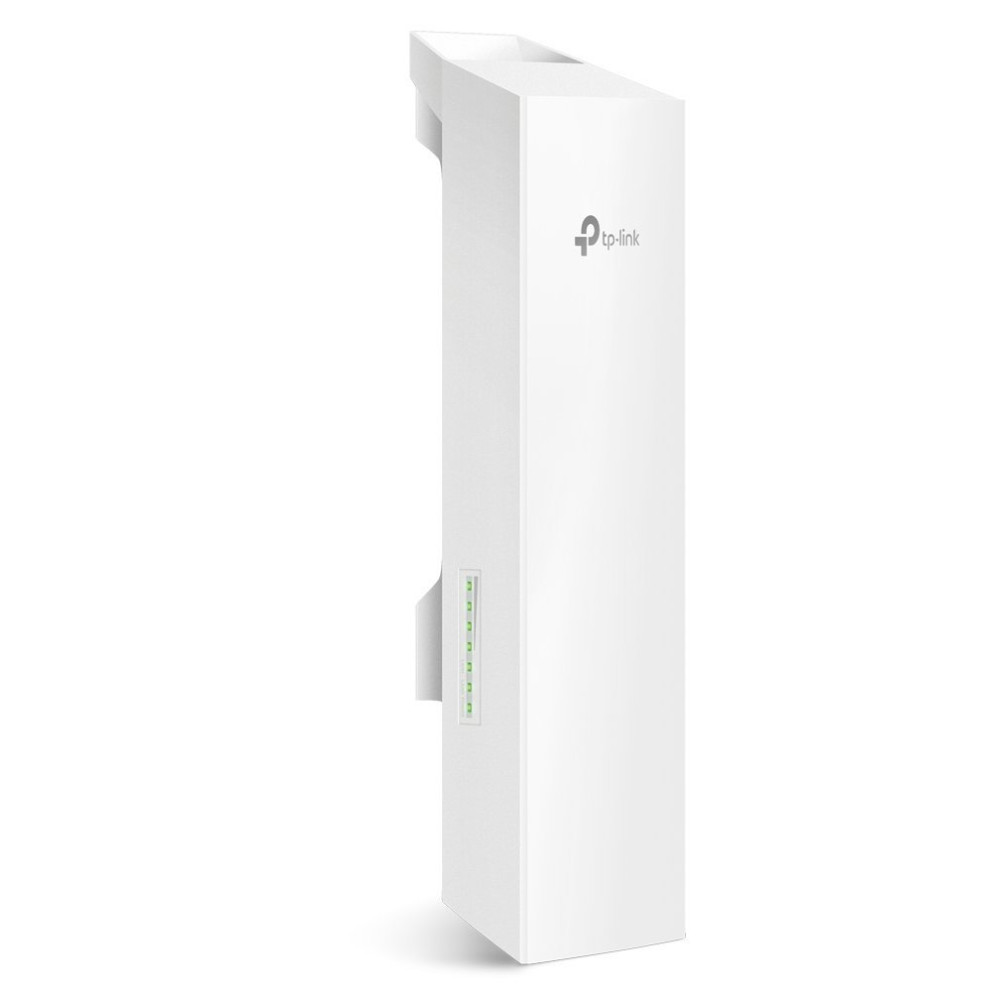
 | Outdoor AP | 01 | High Power 300Mbps AP/Client  - 15dbi Panel antenna  - WPA/WPA2 encryptions for defense against security threats  - Seamlessly compatible with 802.11 a/n devices  - Supports 24V/1A PoEAC 1200 Mbps dual band access Point |  | 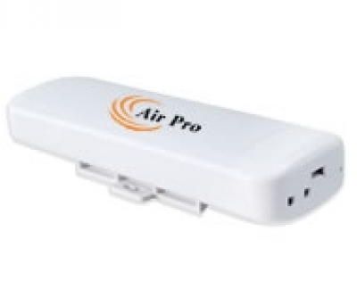
 | AIRPRO XDS9500S | 02 | AIRPRO XDS9500S 500MW, 300MBPS HIGH SPEED  QUICK OVERVIEW  - High Power 300Mbps Access Point  - 2*5 dbi MIMO Antenna  - WPA/WPA2 encryptions for defense against security threats  - Seamlessly compatible with 802.11b/g/n devices  - Supports 24V/1A PoE  - Support Multiple SSID  - Support 802.1Q VLAN |  | 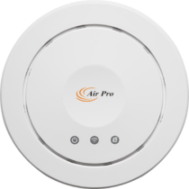
 | Xiaomi Mi | 03 | Xiaomi Mi WIFI Router 4C 64 RAM 802.11 b/g/n 2.4G 300Mbps 4 Antennas Smart APP Control Band Wireless Routers Repeater |  | 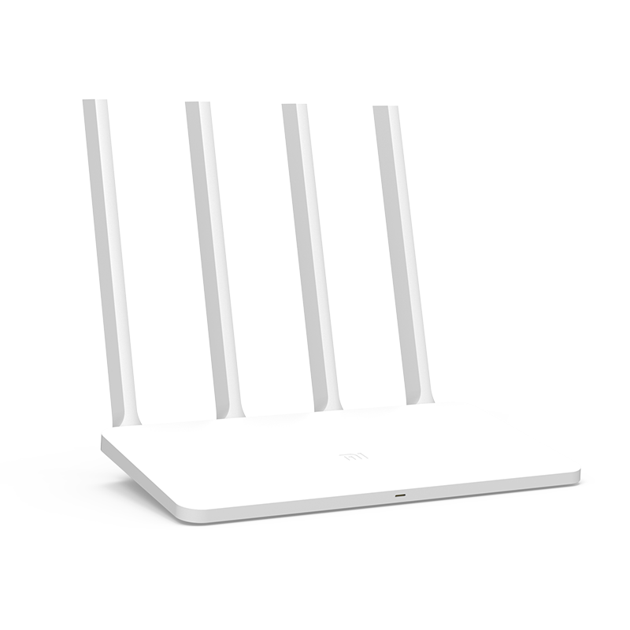
*480 desktops connected through fiber line (CAT 6) for better speed.
* with access 100 MBPS
* students of total laptops connected to Wi-Fi – 1000

 | Prompt leased line with fiber connectivity of 30 Mbps | 02 | Prompt  480 |  | 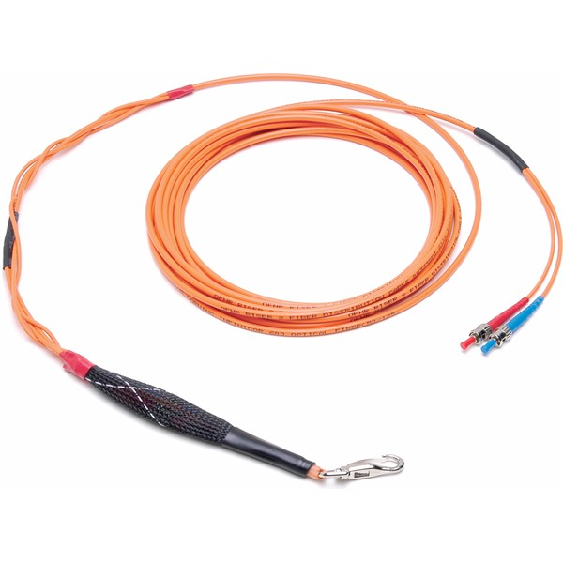
13. | BSNL Broad band connection of 5 Mbps | 01 | BSNL |  | 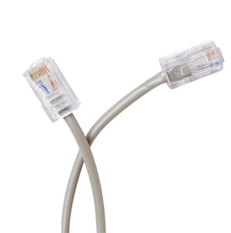
14. | Jio Fiber Connection 100 Mbps | 01 | Jio Fiber |  | 
 | - Each student gets 1.5 GB per session per student. Students can connect for multiple session meaning unlimited data for students in addition to college internet network.
15. | D-Link Switch DES104D | 08 | MAC Address Table Size | 8K
15. | D-Link Switch DES104D | 08 | Switch Fabric | 48Gbps Forwarding Capacity
15. | D-Link Switch DES104D | 08 | Transmission Method | Store-and-Forward
15. | D-Link Switch DES104D | 08 | Diagnostic LEDs | Per Unit: Power  Per Port: Activity/Link, Speed
15. | D-Link Switch DES104D | 08 | Packet Buffer Memory | On ship: 512KBytes Buffer Memory per Device
15. | D-Link Switch DES104D | 08 | Max Power Consumption | 19.1 Watts
15. | D-Link Switch DES104D | 08 | QoS | 802.1p (4 Queues)
15. | D-Link Switch DES104D | 08 | Total Ports | 24
15. | D-Link Switch DES104D | 08 | Interface RJ-45 | 10/BASE-T, 100BASE-TX, and 1000BASE-T
15. | D-Link Switch DES104D | 08 | Description | 24-Port Gigabit Switch, Desktop/Rackmountable, D-Link Green
15 | D-Link Switch DES1024D | 04 | MAC Address Table Size | 8K
15 | D-Link Switch DES1024D | 04 | Switch Fabric | 48Gbps Forwarding Capacity
15 | D-Link Switch DES1024D | 04 | Transmission Method | Store-and-Forward
15 | D-Link Switch DES1024D | 04 | Diagnostic LEDs | Per Unit: Power  Per Port: Activity/Link, Speed
15 | D-Link Switch DES1024D | 04 | Packet Buffer Memory | On ship: 512KBytes Buffer Memory per Device
15 | D-Link Switch DES1024D | 04 | Max Power Consumption | 19.1 Watts
15 | D-Link Switch DES1024D | 04 | QoS | 802.1p (4 Queues)
15 | D-Link Switch DES1024D | 04 | Total Ports | 24
15 | D-Link Switch DES1024D | 04 | Interface RJ-45 | 10/BASE-T, 100BASE-TX, and 1000BASE-T
15 | D-Link Switch DES1024D | 04 | Description | 24-Port Gigabit Switch, Desktop/Rackmountable, D-Link Green





